**Web-Based Medical Record Management System**

**of Bambang National High School**

**______________________________**

A Capstone Project Proposal

Presented to the

Faculty of the School of Engineering, Architecture and Information Technology

Saint Mary’s University

Bayombong, Nueva Vizcaya

**______________________________**

Fitzfedrix E. Fabelico

Brent Joshua A. Olpindo

Adviser

Rocel Audrey J. Batara

**JANUARY 2023**

# Table of Contents

Table of Contents 2

List of Figures…………………………………………………………………………………. 4

List of Tables………………………………………………………………………………….. 5

CHAPTER I 6

Introduction……………………………………………………………………………………. 6

Related Literature and Studies………………………………………………………………… 7

Conceptual Framework..…………………………………………………………………….. 11

Statement of the Problem……………………………………………………………………... 12

Significance of the Study …………………………………………………………………….. 14

Scope and Limitations………………………………………………………………………... 15

Definition of Terms…………………………………………………………………………... 16

CHAPTER I I 17

Research Design……………………………………………………………………………… 17

Research Locale………………………………………………………………………………. 17

Software Development………………………………………………………………………... 18

Development Tools…………………………………………………………………………… 20

System Architecture………………………………………………………………………….. 21

Instrumentation……………………………………………………………………………….. 23

Data Gathering Procedure…………………………………………………………………….. 24

Data Analysis………………………………………………………………………………… 26

Software Requirments………………………………………………………………………. 27

Hardware Requirments……………………………………………………………………… 27

CHAPTER III 28

The Existing Practices and processes of the school clinic………………………… 27

The Problems and Challenges encountered in the existing practices ……………...29

and process of the school clinic

What system can be developed to support the management of the……………….. 30

school clinic

What is the extent of compliance of the web-based clinic…………………………30

management system of Bambang National High School with

ISO Standards

System Development………………………………………………………..33

CHAPTER IV 40

Summary of Findings……………………………………………………….40

Recommendations…………………………………………………………..40

Appendices

Appendix A: Inform Consent Form……………………………………………………41

Appendix B: Interview Questionnaire ………..………………………………………45

Appendix C: Evaluation Form………………………………………………………..49

Appendix D: Prototypes……………………….……………………………….……..57

Appendix E: Answered Interview Questions…………………………………………61

Appendix F: Observation……………………………………………………………..65

Appendix G: Interview with the nurse………………………………………………..67

Appendix H: Document Review………………………………………………………69

Appendix I: Implementation Plan………………………………………………….….71

Curriculum Vitae: ……………………………………………………………..……78

### 

### List of Figures

Figure

1 Conceptual Framework 11

2 School Campus of Bambang National High School 17

3 RAD Model Development 18

4 System Architecture 22

5 Login Page 33

5.1 Clinic Dashboard 34

5.2 Reports (Nutritional Details) 34

5.3 Nutritional List 35

5.4 Vaccination Reports 36

5.5 Deworming Reports 36

5.6 Settings (Grade and Section) 37

5.7 Settings (Users) 37

5.8 Student Patient List 38

5.9 Teacher Patient List 38

6 Prototype (Login Page) 58

6.1 Clinic Dashboard 58

6.2 Reports 59

6.3 Users 59

6.4 Medical Form 60

6.5 Referral Form 60

### List of Tables

Table

1 Table of Participants 22

2 Measurement of the Extent of Compliance with ISO 25010:2015 26

Software Quality Standards

3 Software Requirements 27

4 Hardware Requirements 27

5 Extent of Compliance of Proposed System of ISO 25010:2015 31

Software Quality Standard Per Dimensions

6 Summary on the Extent of Compliance of Proposed System 40

of ISO 25010:2015 Software Quality Standard Per Dimensions

**CHAPTER I**

**PROBLEM AND REVIEW LITERATURE**

**Introduction**

The World Health Organization (WHO) advised its member nations to develop long-strategic plans for eHealth or the use of ICT for health in 2005 after realizing the potential of leveraging information and communication technology (ICT) to improve the delivery of health services and systems. A national health information system strategy was adopted in the Philippines in 2007 (Claro-Acacio et.al, 2022).

The corona virus disease 2019 (Covid-19) has a great effect on the educational system in the Philippines. All colleges, universities, and schools have been ordered to close due to the epidemic. The entire system of education is being affected by this. Making decisions about the educational system's policy is difficult for policymakers. Online and offline teaching are both happening (Tarkar, 2020). Online platforms are utilized for teaching like Google Classrooms, WebQuest, and other online resources, yet the majority of teachers lack the necessary skills to deal with online education (Toquero, 2020). Teachers and students used smartphones to communicate messages, notes, and resources via text messaging, e-mail, Facebook Messenger, and Twitter because they had limited access to personal computers or unstable internet connectivity (Simbulan, 2020).

To monitor and safeguard the spread of Covid-19 in schools and in other institutions, pen and paper have traditionally been used to manually record medical information, and this method has proven to be reliable. Contrarily, paper deteriorates over time and pen-written records fade, compromising the long-term viability of record-keeping, regardless of how secure the filing storage is. In the healthcare industry, consistency in documentation is highly appreciated since it enables the monitoring of patients' health, which may help to avoid more serious issues later in their life. In addition, water, fire, insects, and even lightening might all utterly destroy a paper archive (Almacen & Cabaluna, 2021). A complete collection of patients' medical records stored in a computer system known as an electronic medical record (EMR) system offers vital clinical information about patients (Shahmoradi et al., 2017).

To record and manage student medical records using computer technology without having to physically deal with patients or pupils is crucial for eliminating Covid-19 in educational settings. A web-based medical record management for schools are relevant to prevent the spread of Covid-19. Moreover, it can also store the data faster in the system database without the use of the pen and paper.

**Medical Record System**

Health systems depended primarily on clinic information systems and international governmental organizations in reaction to Covid-19 (Reeves et al.,2019). The healthcare sector has experienced a massive improvement in how it operates and engages with patients and healthcare providers. Information digitization and a variety of processes becoming automated (Williams, 2022).

Modern developments in the technology era include web-based applications (WBA). WBA enables users to communicate with a distant server through a web browser interface(lvivity.com).

The said WBA are a key tool for replacing desktop programs, having a significant impact on both small and large organizations. Web-based applications had limited capabilities in the past, but as technology advanced, the system's potential improved. Web-based software therefore provides significant benefits over conventional methods and favors different enterprises (aezion.com)

The development of a web-based clinical data management system aims to support and automate clinic everyday operations. A system called the Clinic Management System can assist the clinic in managing its everyday operations. The medical record system primarily keeps all the patient records of those who have received treatment from a hospital that employs this system (Tergundi et al., 2017). Without a completely integrated system, it can be difficult to exchange patient records, such as prescription information, referral information, diagnosis status, and appointment schedules, between different clinic units when patient medical records grow in size. Access to patient records also needs to be private. Numerous studies on healthcare services have been undertaken to solve difficulties such as inconsistent medical records, slow record storage and retrieval, and paper-based methods (Muhammad & Garba, 2019).

A reliable and accurate health report can be described in a good medical record file. Medical records play a significant role in the collection, processing, and display of health information. This can be done manually or electronically (Nuryati & Widayanti, 2015). Numerous elements play a role in the success of the implementing electronic medical records requires careful preparation, a committed team, and backing from facility management, financiers, and computer system developers (Mashoka et al., 2019).

Here in the Philippines particularly in Nueva Vizcaya, one of the biggest secondary schools in the province is the Bambang National High School (BNHS). One of the challenges set by the Department of Education is the opening of classes this November, 2022. However, it seems the said school is not yet ready to monitor and prevent spread of the said Covid-19 disease in school premises. The BNHS has a clinic that currently uses the traditional paper-based system and folders to store all the pertinent medical information. This will be a great challenge for the school nurse and health workers because the school has a big population that includes 3,923 students for both junior and senior high school, and 127 teachers and employees for the school year 2020-2021. The use of the conventional manual or paper-based record management system has a number of drawbacks which include inefficiency, accuracy, time consumption, inconvenience, hard, and slow-moving pace for medical service. Given this context, there is a need to automate the current manual systems (Agu, et al., 2016).

At BNHS, the clinic's current system is less effective because all of its medical data are kept on paper and stored in folders. For instance, it is more difficult to make various changes to medical records, such as staff information, because paper labor is required (Adebisi, et al. 2015). Moreover, it is time-consuming for the clinic staff because they need to organize the medical records from time to time (Adebisi, et al. 2015). To manage the clinic services and deal with the lengthy, traditional clinic process, a web-based application will be created in the school clinic to be more efficient, organized, protected and less time consumed by the school nurses in managing the records (Jibrin & Salisu, 2019).

**RAD Model**

One of the famous applications used in medical record management system is the Rapid Application Design (RAD) because it is now the best strategy for system development. Because of RAD's rapid deployment, most people favor it, especially in the medical field, in hospitals, and in clinics (Delima et al., 2017; Lacar & Maribao, 2020; Pratiwi et al., 2022). In comparison to other approaches, RAD can offer higher-quality outcomes more quickly, satisfies the demand for a tight schedule (Kwan, 2015), and it results in an accurate system and minimizes error rates in medical record system (Pratiwi et al., 2022). Moreover, RAD is useful in monitoring the productivity and performance of each member of the system in order to gain optimal development process (Delima et al., 2017).

According to James Martin, the Rapid Application Development (RAD) paradigm provides quick creation of high-quality systems at a low cost and is more adaptable to changing customer needs (Fatima et al., 2014). It is a quick process which consists of development, testing, and feedback (Despa, 2014). Software development is done using the RAD technique because can speed up the software development process (Delima et al., 2017) and also the stages are structured (Widiyanto, 2018). Moreover, employing the RAD method in software development is required in order for clinical operations to function successfully at the Clinic Systems (Pratiwi et al., 2022).

Software models and standards have been created by the International Organization for Standardization (ISO) to describe and assess the quality software, including those for systems that maintain medical records (Hussain & Mkpojiogu 2015). Software quality is governed by two ISO frameworks and standards: ISO 9126-1 (SO/IEC9126-1 2001) and as well as its replacement ISO 25010 (ISO/IC 250 10 2011). The ISO views software quality from various angles, including internal and external quality as well as quality in usage (Herrera et a1., 2010). Furthermore, the ISO/IEC 25010 refers to the product's usability as "the extent to which a product is utilized by specific users satisfies their needs to achieve specified goals with effectiveness, efficiency, safety, and satisfaction in certain contexts of usage" (Bevan, 2010)

Hence, with the pressing needs to automate the medical record management system at Bambang National High School, the researchers worked on a research on the development of a web-based medical record management system of BNHS based on the conceptual framework outline and discussed below.

**Conceptual Framework**

Every research paper is anchored on concepts or theories that serve as the foundation or backbone for the paper*.* Below presents the Input-Process-Output (IPO) model of the study

Feedback

Proposed Web-Based Medical Record Management System of Bambang National High School

**Process**

Existing practices and processes of the school clinic

Problems and challenges encountered in the existing practices and processes of the school clinic

Data Sets

* Id number
* Name
* Address
* Contact Number
* Section
* Year level
* Patient medical records
* Nutritional status report
* Deworming record
* Interview

ISO 25010:2015

Rapid Application Development Model

* Requirements Planning
* User Design
* Construction
* Cutover

Development tools

* Visual Studio code
* HTML
* MYSQL
* WampServer
* Code Igniter

**Output**

**Input**

**Figure 1.**Conceptual Framework

The researchers uses the IPO model to easily visualize the structure and effectively analyze the processes needed for the proposed system. It provides a roadmap in the development and implementation of the Web-Based System for the Record management of Bambang National High School. The IPO model consists of three stages with a feedback mechanism.

The INPUT presents the variables needed for the development of the proposed system. This includes the manual of operations, existing practices and processes of the clinic of Bambang National High School as well as the problems encountered in the school clinic. Other inputs include the data sets for the patients and students. The ISO 25010:2015 will be used in the development and evaluation of the proposed system.

The PROCESS presents the different phases in developing the proposed system. In this stage, inputs will be analyzed, processed and evaluated. This includes interviews, document analysis and observations to analyze the practices and problems of the clinic of Bambang National High School. The researchers will be using Rapid Application Development (RAD) Model in developing the proposed system.

The OUTPUT is a Web-Based Medical Record Management System of Bambang National High School. The feedback mechanism helps the researchers to gather suggestions and comments from nurse, health workers and, IT experts to further improve the proposed system.

**Statement of the Problem**

1. What are the existing practices and processes of the school clinic in terms of?
   1. Recording patient information
   2. Nutritional status and deworming records
   3. Updating the check-up records of patients
   4. Generating patient’s reports
2. What are the problems and challenges encountered in the existing practices and processes of the school clinic in terms of?

2.1. Recording patient information

2.2. Nutritional status and deworming records

2.3. Updating the check-up records of patients

2.5. Generating patients’ reports

3. What system can be developed to support the management of the school clinic?

4. What is the extent of compliance of the proposed system with ISO 25010:2015 Software Quality Standards as assessed by the user-participants and IT expert-participants in terms of the following?

4.1 Functional Suitability,

4.2. Performance Efficiency,

4.3. Compatibility,

4.4. Usability,

4.5. Reliability,

4.6. Security,

4.7. Maintainability, and

4.8. Portability?

**Significance of the Study**

With the development of a web-based medical record management system at Bambang National High School, the said system can help bring the patient’s data into the school’s database. This could help the administrator’s task to be easier, accurate, and reliable in processing, storing, and generating patient medical reports. Specifically, the said project could be significant in one way or another to the following:

**Clinic.** The suggested approach makes things more systematic and organized in the clinic. Moreover, this could help the clinic maximize the time spent with their clients, and make the clinic more profitable. Hence, with this project clinic routines will be simplified and automated.

**Nurse.** The suggested solution makes managing the clinic simpler and practical for the nurses and health workers when it comes to accessing, storing, and generating patients’ medical records.

**Patients**. The patients which include the teachers and the students could easily provide and retrieve their past and current medical records with ease and convenience. With the aid of the said system, the patients will be served faster and better due to the advent of technological advancement in the medical record system.

**School Administrators**. The school administrators could easily checked, monitor, and evaluate the data records of both the teachers and the students. The said web-based record management system could assist school administrators to plan and proposed guidelines, policies, and actions related to the prevention of the spread of Covid-19 in the school and in the community.

**Future Researcher.** The result of this study could benefit future researchers as baseline information to better improve the proposed project. Moreover, this could help them to benchmark on the other applications of the said project in other situations that has something to do with web-based medical record management system.

**Scope and Limitations**

This study focuses on developing a software application for the medical record management system of Bambang National High School (BNHS). This includes the management of patient’s medical records with the help of the database system. Since the school use manual or traditional way of storing patient’s medical clinic records like envelopes and folders for medical files, the proposed application will be used within the premise of the BNHS’s clinic. The proposed project includes the features of the web-based medical record management system such as recording patient information, nutritional status and deworming records, updating the check-up records of patients, medical check-up of patients, and in generating patient’s reports.

The patients in this study includes all employees and students of the said school. The respondents of the study will be limited to the school administrators, teachers, non-teaching staff, and students of BNHS. It also includes IT experts in the field as respondents.

The proposed system/application was developed using PHP Code Igniter framework, SQLyog, and WampServer that runs on a Local Area Network (LAN) of BNHS. The system can only be accessed within the local area network of BNHS which is located at the school clinic. The school Principal and the clinic staff could easily monitor the patient’s health records based on the system database.

**Definitions of Terms**

* Information System – A system that is used for personal records of the users within the database.
* Medical Record System – A system that is used for medical records of the patients within the database.
* Web Based - Users can communicate with a distant server using a web browser interface by using applications, a specific kind of software.
* Rapid Application Development (RAD) – A development model that uses prototyping and fast feedback by the clients are given in the process.
* Patient – A person undergoing medical treatment or registered to do so.
* Nurse – A person that is authorized to give medical treatment to the patient.
* Clinic – A place where a patient goes to check up on their health or sickness.
* School Administrator – A person who manages all of the school operations, from establishing a secure learning environment to controlling school spending.
* School – A place where students study, and learn with the guidance of the teachers.

**Chapter II**

**METHODOLOGY**

This chapter discusses the study's instrumentation, research design, data collection process, and data analysis methods. This sections also include the data collection and analysis techniques used by the researcher in gathering the necessary information for the development of the said project.

**Research Design**

The developmental research design was employed to produce a data-based understanding of the systematic results of practices in school clinics. This pragmatic form of research is a strategy for developing new practices, methods, and tools based on a thorough examination of certain instances. Hence, the developmental research can have the purpose of either producing generalized judgments or legal declarations or creating information that is specific to a situation for issue solving function (Richey & Klein, 2005).

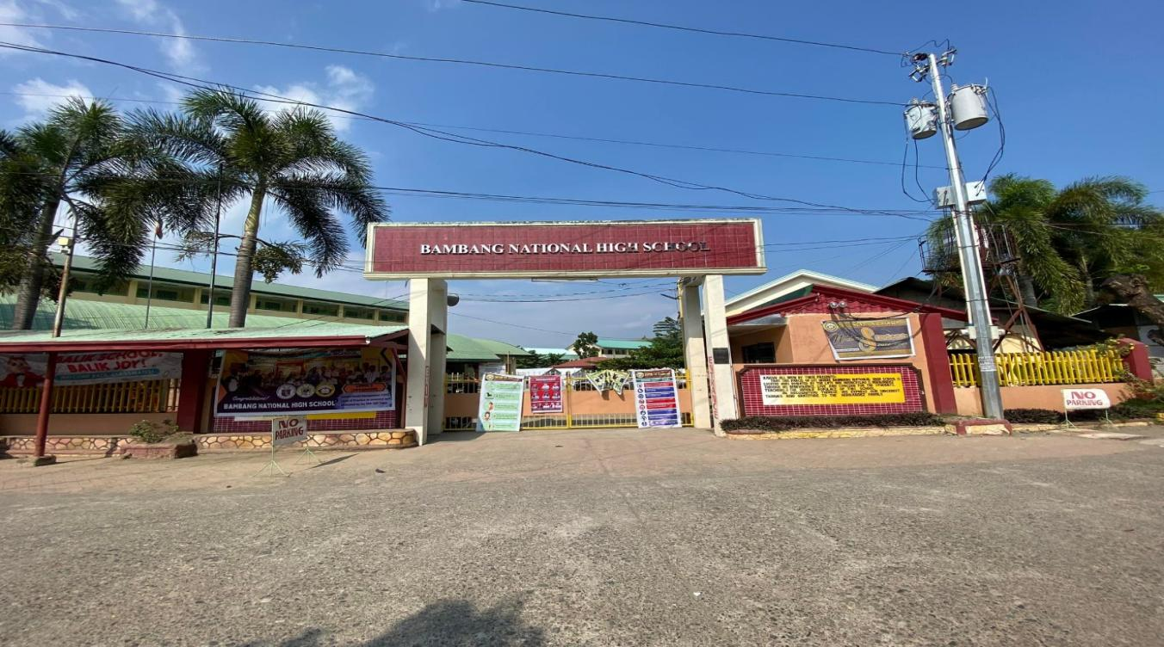**Research Locale**

**Figure 2.** School Campus of Bambang National High School

The campus of Bambang National High School is a public high school which offers Junior High and Senior High School. The campus is located in particularly in Boyie Street, Buag, Bambang, Nueva Vizcaya. The gathering of data will be done in the campus of Bambang National High School.

**The Software Development**

The development of the medical record management system of Bambang National High School was based on Rapid Application Development (RAD) model process. Some of the reasons for employing the RAD in the development of the web-based medical record system of BNHS includes the following: the RAD method used because the steps are structured (Widiyanto, 2018) and it is an efficient approach to software development (Irfan et al., 2020). System development uses quicker and shorter cycle periods (Putra & Lolly, 2021).Due to the method being broken down into modules and being applicable to small-scale systems, the generated software can be seen without having to wait a long time (Hasanudin et al., 2019; Sintawati, 2018). As a result, there is no longer a need for original design with respect to software development (Kusmiati & Ansori, 2015; Suryanto & Maliki, 2022).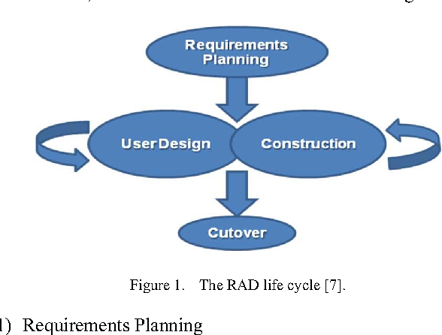 The RAD Model Cycle as shown in Figure 3 will be patterned from Ismail et al. (2016).

**Figure 3**. The RAD Model Cycle (Ismail A., et al, 2016)

The following are the phases of the RAD model will be adapted from (Ismail A., et al, 2016):

*Requirements Planning*. During this stage, the current situations, practices, and problems are studied. Moreover, in this first phase of the study, the researchers conducted interviews and data gathering procedures on the participants of the study to know the practices, processes, and problems/challenges for the needed data information in the project. Planning for the development of the project was done to know what is applicable to the system and how it functions in the system. The researcher also identified the existing strengths and weaknesses of the clinic and what are things to be improved. Hence, this phase establishes the blueprint of the whole project system.

*User Design.* After the first phase of planning and having pointed out the requirements, user design was done. In this phase, the clients and the developers interacted to find out the design process of the system that was developed. Data flow and the process pointed out in detail for a precise result that was considered. The prototype was done in this stage to test the program. In each prototype, the client tested each one to provide feedback to refine the functionalities of the system until it reached the satisfaction of the client and the user’s needs.

*Construction.* In this third phase, construction was done when all requirements and user design have been completed and incorporated in the the first and second phases. During this stage, the processes such as designing, coding, testing, and modifying the system was done to developed the web-based medical record management system.

*Cutover.* In this stage, implementation and installation of the medical record management system of BNHS was done. During this stage, the users such as the school administrators, nurse, health workers were trained on how to operate and test the developed medical record management system. The evaluation of the system was conducted using the ISO 25010 Software Quality Standard evaluation questionnaire that were evaluated by the users and the IT experts.

## Development Tools

The researchers will use the following tools to fully develop the system primarily.

**HTML**

Information obtained from the Internet was formatted using HTML, or hypertext markup language. It served as a fundamental building component to specify the web structure.

**CSS**Websites were styled and laid out using CSS, or Cascading Style Sheets. It is used to add decorative elements like animations and the division of text into columns, as well as alter the size, spacing, color, and font of the contents.

**JavaScript**

JavaScript is a dynamic programming language often used in the Web. It is used to enhance web pages; it also helps interact with the users and create dynamic web sites.

**Visual Studio Code**

The debugging, task execution, and model control functions of Visual Studio Code make use of a condensed version of the code editor. It offers the tools developers require in a speedy cycle of code-build-debug, leaving more complex workflows to IDEs with greater functionality.

**WAMP Server**

A virtual computer server that acts to connect computer locally or the used of LAN connection. WAMP also stands for Windows, Apache, MySql, PHP.

**Code Igniter**

A computer software that used for web development. It is the backbone and serves as the framework of the web development process for building the web site with the PHP programming language.

**SQLyog**

A GUI software that helps organized and store data with the used of the its built-in database software.

**Web-based - Medical Record Management System Architecture**

The web-based medical management system (WB - MRS) architecture was used as the basis in the development of the said project. Moreover, the WB-MRS architecture as shown in Figure 4 was designed by the researchers. This facilitated and assisted the researchers in the developmental process that was employed in this study.

The processes that was implemented in this are described as follows. First, the patient was checked by the school nurse. The school nurse inputs patient’s details and edits additional information, and/or delete unnecessary information from the patient’s medical details. This information is stored in the file server and clinic record database.

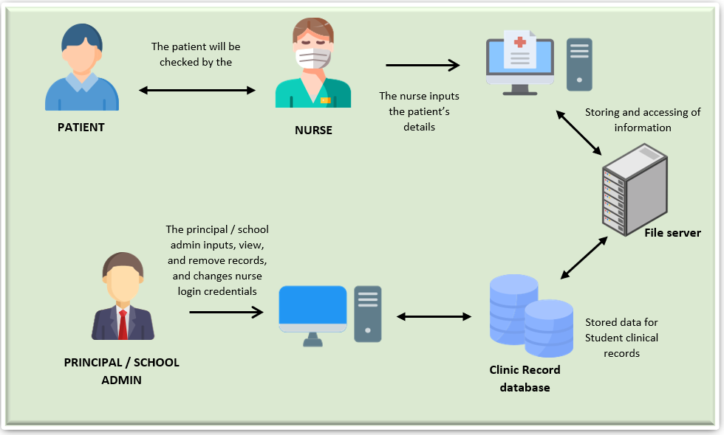 The entire system runs with the use of Local Area Network (LAN), which does not need to use an internet connection. The system relies on the installed server on the computer terminal that acts as the server for the said system and its database.

**Figure 4.** WB-MRS System Architecture

**Participants and Sources of Data**

The participants of this study has a population size of 4. However, the 1 participant which is the nurse, was selected to obtain the necessary data for the development of the web-based record management system of the school. Table 1 shows the respondents' distribution.

**Table 1.** Participants of the Study

|  |  |  |
| --- | --- | --- |
| **Respondents** | **Population** | **Percentage** |
| Nurse/Health workers | 1 | 25 |
| IT Specialists | 3 | 75 |
| **Total** | **4** | **100** |

The study involved 1 Nurse/Health workers (25%) and 3 IT Specialist (75%). Direct interview was done to obtain the relevant and necessary information in the design and development of the said system. The direct end users of the said project who are also the respondents of this study included the school nurse/health workers and the Information Technology (IT) specialists were selected to obtain relevant information for the development the web-based medical records management system of the target school.

The school nurse or healthcare professionals who work in the clinic were selected because they provided important information on the technical aspects of recording, organizing, updating, and generating patient information and medicine history of patients. Conversely, the IT specialist were chosen as participants due to their technical expertise, excellent knowledge, innovative ideas, and objective judgment in the development and improvement of web-based medical records management system of the school.

**Instrumentation**

*Interview Guide*

With the use of an interview guide, the researchers conducted interviews with the school nurse/health workers in order to have a better understanding of the clinic’s processes and methods. The school nurse provided all of the required information that is deemed necessary in the development of the said proposed web-based medical record management system. The interview guide includes questions on how the nurse and health workers they perform processes such as recording patient information, nutritional status, and deworming records, updating the check-up records of patients, check-up of patients, and in generating patients’ reports.

*Document Review*

The researchers looked over the documents kept by the school nurse which contains the data about medical records of the patients. The data that was gathered includes the patient’s medical records, nutritional status report and deworming records which are the important components of the development of the web-based medical record management system.

*Observation*

The researchers used direct observation in the clinic in obtaining the knowledge on the processes and methods of the school clinic operations. The observation that was performed helped the researchers about the manual recording and storing of patient’s data. Moreover, the researchers also observed how the nurse and health workers updated their patient’s medical records as well as on how they generate medical reports that are submitted to their school administrators and to other concerned end users.

**Data-Gathering Procedure**

To develop the proposed project, the researchers followed the data-gathering procedure. The researchers sought approval from the school principal for the conduct of the study in their school. Once the school Principal granted the request, the researchers conducted the interviews to the respondents such as the school nurse/health workers. This process helped the researchers determine the existing practices, processes, problems, and challenges in managing the medical clinic record of the school.

After all, the information was gathered from the interview, the researchers designed and developed the project on the web-based medical record management system of the school.

**Treatment of Data**

**Ethical Consideration**

This study was submitted for ethics review/assessment and approval to Saint Mary’s University Research Ethics Board (SMUREB), headed by Engr. Teofilo Sagabaen (email: reb@smu.edu.ph; mobile: 09177053041), A218, Second Floor, Fr. Godfrey Lambrecht Building; SMU Main Campus, Ponce Street, Don Mariano Marcos; Bayombong, 3700 Nueva Vizcaya, Philippines.

The study was carried out in an orderly and convenient way for the participants. Before conducting the interview, the researcher asked permission to the principal to conduct data with the particular participants needed in our study. A brief consent form was given to the principals and participants which are the school nurse/health worker that were interviewed. All information asked by the researchers was provided by those who consented to participate. In exchange for their time and effort, the study participants received compensation for the data connection used during the data collection sessions. The researchers have guaranteed the participants that any data collected in exchange for compensation were kept private and confidential.

Only the researchers had access to the participant data, which was kept strictly confidential. Data and participant information were restricted to the researchers alone. The researchers' computers were used to save all the obtained data, which would not be shared with anybody else. To protect participant identities and maintain the confidentiality of the information, the researchers will disseminate the data they have collected to others. Once the research was concluded, the researchers removed and deleted all the participant’s data information that were obtained, to protect their confidentiality. The deleted files were gone and never be recovered by anyone. The study was expected to provide an important asset or role in the school clinic with their record management which entitled Web base medical record management system of Bambang National High School. Throughout the essay, references to data and opinions presented by diverse authors have been documented using APA style citations. The integrity of the acquired data and findings was not compromised by the researchers' receipt of any benefit from this study. This paper does not disclose any declared conflicts of interest.

**Data Analysis**

Statistical tools such as frequency, percentage, and mean will be employed in this study. Moreover, the degree of compliance of the proposed system with ISO 25010:2015 Software Quality Standards will be assessed using the weighted mean. The Likert scale that will be used to score the system's level of compliance according to ISO 25010:2015 software quality standards is presented in Table 2.

**Table 2.** Measurement of the Extent of Compliance with ISO 25010:2015 Software Quality Standards

|  |  |  |
| --- | --- | --- |
| **Mean Range** | **Developmental Equivalent** | **Interpretation** |
| 4.50 – 5.00 | OUTSTANDING or the measure developed in the item is compliant to a very great extent. | Very High degree of compliance. |
| 3.50 – 4.49 | VERY SATISFACTORY or the measure developed in the item is compliant to a great extent. | High degree of compliance |
| 2.50 – 3.49 | SATISFACTORY or the measure developed in the item is compliant to a moderate extent. | Moderate degree of compliance |
| 1.50 – 2.49 | FAIR or the measure developed in the item is compliant to a little extent. | Low degree of compliance |
| 1.00 – 1.49 | POOR or the measure developed in the item is compliant to a very little extent. | Very Low degree of compliance |

**Software Requirements**

The computer programs that will be used in developing the system includes the PHP, CSS, HTML, JAVASCRIPT, CODE IGNITER, WAMPSERVER and MYSQL (Sqlyog) for database management is shown in Table 3.

**Table 3.** Software Specifications

|  |  |
| --- | --- |
| **Component** | **Specifications** |
| Operating System | Windows 7 and above |
| Database Application | MySQL (SQLyog v.10) |
| Software Development | Visual Studio Code |

**Hardware Requirements**

To implement the proposed project, the school needs to conform to the suggested hardware requirements as presented in Table 4. These hardware requirements include the Slog computer hardware, peripherals, and system requirements.

**Table 4.** Recommended Hardware Specifications

|  |  |
| --- | --- |
| **Component** | **Specifications** |
| CPU | Intel Core i3 |
| Memory | 4GB |
| Hard Disk Space | 1TB |
| Monitor | 14” LCD |
| Keyboard | 101/102 Keyboard |
| Mouse | Microsoft USB |
| Printer | Epson 2100 |

**CHAPTER III**

**RESULTS AND DISCUSSION**

The study's conclusions and data analysis are presented in this chapter. The results and discussion are presented as what was stated in the problem.

1. **The Existing practices and processes of the school clinic in terms of:**

* **Recording patient information**

The Advisers and subject teachers endorse students who are in need of medical assessments and are given first aid treatment and/or referral for further examinations to Regional Hospital Unit (RHU) and Hospitals. Medical records are kept at school clinic and these are kept in folders that are arranged per grade and section, that are place at the clinic’s cabinet.

* **Nutritional status record**

The Nutritional status records are well recorded, because MAPEH teachers are the one taking the records and are submitted to the division office in time and which the nurse or clinic will keep the records of the student.

* **Deworming records**

The deworming records are taken from the number of students given the medicine and those who refuse, which is done by the school nurse.

* **Updating the check-up records of patients**

The school clinic lacks records for updating the check-up records of the patients. Appointments and scheduling of check-up of patients, is only the referred students by their adviser or teacher which are given assessments.

* **Generating patient’s reports**

The reports are generated and consolidated by the nurse on which advisers are required to submit to their respective curriculum chairs.

The medical records are kept as long as the student is enrolled in the school before the disposal of the records.

1. **The problems and challenges encountered in the existing practices and processes of the school clinic**

The school designates nurses who are also teachers, cannot function as full-time school nurses. Records were not organized and the school lack facilities as well.

* **Recording patient information**

Due to the increasing number of students, they do not have a system that may keep records and update faster the patient’s medical records.

* **Nutritional status record**

The Nutritional status records are well recorded because MAPEH teachers are the one taking the records and are submitted to the division office in time but, it is hard for them to keep track of the records with the increasing number of students and patients.

* **Deworming records**

The deworming records are recorded manually and kept in an excel file which they use as a clinic report in the school.

* **Updating the check-up records of patients**

The school clinic lacks records for updating the check-up records of the patients. Appointments and scheduling of check-up of patients, is only the referred students by their adviser or teacher which are given assessments.

* **Generating patient’s reports**

The generating of patient’s reports, the records from the adviser/teachers may sometimes be late in submitting reports or none at all.

1. **What system can be developed to support the management of the school clinic?**

To answer the existing problem of school clinic of Bambang National High School particularly on the management of their clients medical records, the researchers were able developed the Web-based Medical Record Management System that could be helpful in recording patient information providing the nutritional status and deworming records; updating the check-up records of patients; and in generating patients’ reports.

1. **Extent of Compliance of the Proposed Medical Record Management System with ISO 25010:2015 Software Quality Standards**

As assessed by the User-participants and IT Expert-participants, the results in Table 5 showed that the proposed medical record management system has very satisfactory reliability (Mean = 4.38) and a high extent of compliance with software quality standards. Conversely, the proposed medical record management system has an outstanding and very high degree of compliance with quality standards as to functional suitability (Mean = 4.20), performance efficiency (Mean = 4.58), compatibility (Mean = 4.75), usability (Mean = 4.54), security (Mean = 4.65), maintainability (Mean = 4.75), and portability (Mean = 5.00). Moreover, the said medical record management system showed an overall outstanding and very high extent of compliance with ISO 25010:2015 as to the software quality standards as evident in the overall mean rating of 4.63. Thus, the proposed medical record management system can be used in the school clinic of Bambang National High School.

Table 5. Extent of Compliance of the Proposed System of ISO 25010:2015 Software quality standard per dimensions.

|  |  |  |  |
| --- | --- | --- | --- |
|  | **Mean** | **Developmental Equivalence** | **Interpretation** |
| 1. **Functional Suitability** |  |  |  |
| 1. Functional Completeness | 4.50 | Outstanding or very great extent | Very High degree of compliance |
| 1. Functional Correctness | 4.50 | Outstanding or very great extent | Very High degree of compliance |
| 1. Functional Appropriateness | 4.50 | Outstanding or very great extent | Very High degree of compliance |
| ***Area Mean*** | ***4.50*** | ***Outstanding or very great extent*** | ***Very High degree of compliance*** |
| 1. **Functional Suitability** |  |  |  |
| 1. Time Behavior | 4.75 | Outstanding or very great extent | Very High degree of compliance |
| 1. Resource Behavior | 4.25 | Outstanding or very great extent | Very High degree of compliance |
| 1. Capacity | 4.75 | Outstanding or very great extent | Very High degree of compliance |
| ***Area Mean*** | ***4.58*** | ***Outstanding or very great extent*** | ***Very High degree of compliance*** |
| 1. **Compatibility** |  |  |  |
| 1. Co-existence | 4.75 | Outstanding or very great extent | Very High degree of compliance |
| 1. Interoperability | 4.75 | Outstanding or very great extent | Very High degree of compliance |
| ***Area Mean*** | ***4.75*** | ***Outstanding or very great extent*** | ***Very High degree of compliance*** |
| 1. **Usability** |  |  |  |
| 1. Appropriateness Recognizability | 4.75 | Outstanding or very great extent | Very High degree of compliance |
| 1. Learnability | 4.75 | Outstanding or very great extent | Very High degree of compliance |
| 1. Operability | 4.75 | Outstanding or very great extent | Very High degree of compliance |
| 1. User Error Protection | 4.50 | Outstanding or very great extent | Very High degree of compliance |
| 1. User Interface Aesthetics | 4.25 | Very Satisfactory or great extent | High degree of compliance |
| 1. Accessibility | 4.25 | Very Satisfactory or great extent | High degree of compliance |
| ***Area Mean*** | ***4.54*** | ***Outstanding or very great extent*** | ***Very High degree of compliance*** |
| 1. **Reliability** |  |  |  |
| 1. Maturity | 4.50 | Outstanding or very great extent | Very High degree of compliance |
| 1. Availability | 4.50 | Outstanding or very great extent | Very High degree of compliance |
| 1. Fault Tolerance | 4.50 | Outstanding or very great extent | Very High degree of compliance |
| 1. Recoverability | 4.00 | Very Satisfactory or great extent | High degree of compliance |
| ***Area Mean*** | ***4.38*** | ***Very Satisfactory or great extent*** | ***High degree of compliance*** |
| 1. **Security** |  |  |  |
| 1. Confidentiality | 4.75 | Outstanding or very great extent | Very High degree of compliance |
| 1. Integrity | 4.50 | Outstanding or very great extent | Very High degree of compliance |
| 1. None-Repudiation | 4.50 | Outstanding or very great extent | Very High degree of compliance |
| 1. Accountability | 4.75 | Outstanding or very great extent | Very High degree of compliance |
| 1. Authenticity | 4.75 | Outstanding or very great extent | Very High degree of compliance |
| ***Area Mean*** | ***4.65*** | ***Very Satisfactory or great extent*** | ***High degree of compliance*** |
| 1. **Maintainability** |  |  |  |
| 1. Modularity | 4.75 | Outstanding or very great extent | Very High degree of compliance |
| 1. Reusability | 4.75 | Outstanding or very great extent | Very High degree of compliance |
| 1. Analyzability | 4.75 | Outstanding or very great extent | Very High degree of compliance |
| 1. Modifiability | 4.75 | Outstanding or very great extent | Very High degree of compliance |
| ***Area Mean*** | ***4.75*** | ***Very Satisfactory or great extent*** | ***High degree of compliance*** |
| 1. **Portability** |  |  |  |
| 1. Adaptability | 5.00 | Outstanding or very great extent | Very High degree of compliance |
| 1. Install Ability | 5.00 | Outstanding or very great extent | Very High degree of compliance |
| 1. Replaceability | 5.00 | Outstanding or very great extent | Very High degree of compliance |
| ***Area Mean*** | ***5.00*** | ***Very Satisfactory or great extent*** | ***High degree of compliance*** |
| ***OVERALL*** | ***4.63*** | ***Very Satisfactory or great extent*** | ***High degree of compliance*** |

**System Development**

* 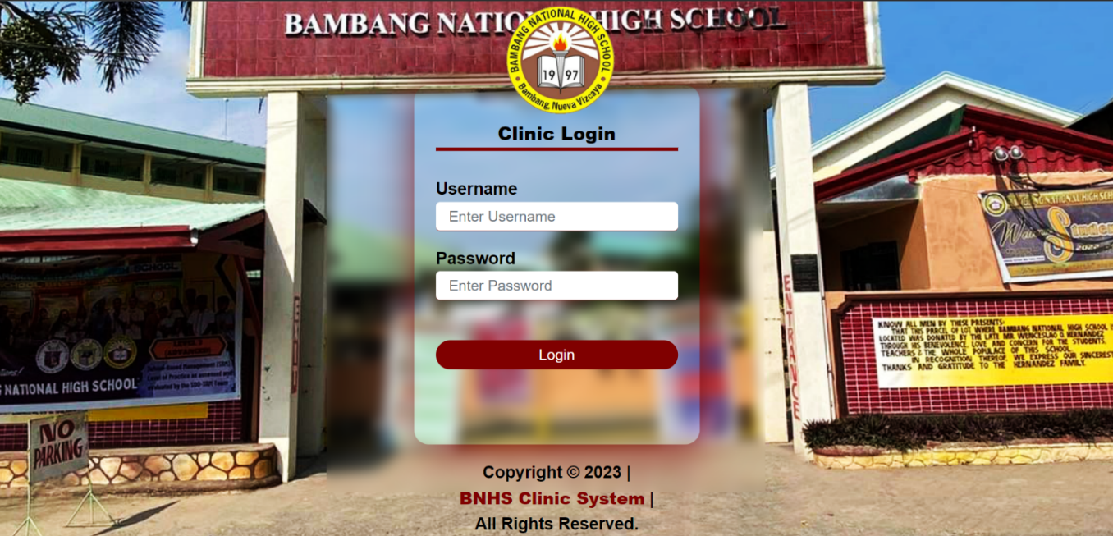**Main Page / Login page**

*Figure 5.* Login Page

**Username -** Users are able to log onto the system using their registered username.

**Password-** Users are able to log onto the system using their registered password.

**Login -** This will enable system login for the user.

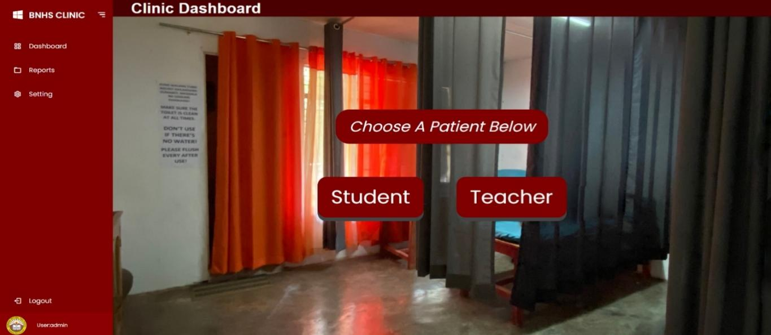**Logout-** This function will return and logout the user to the main page of the system.

*Figure 5.1.* Main Clinic dashboard

**Dashboard Page**- This page serves as the main dashboard of the clinic where the user can choose the type of patient and generates clinic reports.

**Reports –** This page’s function shows and generates the clinic medical reports.

**Setting –** This page’s function displays the grade and section and even the user’s that have

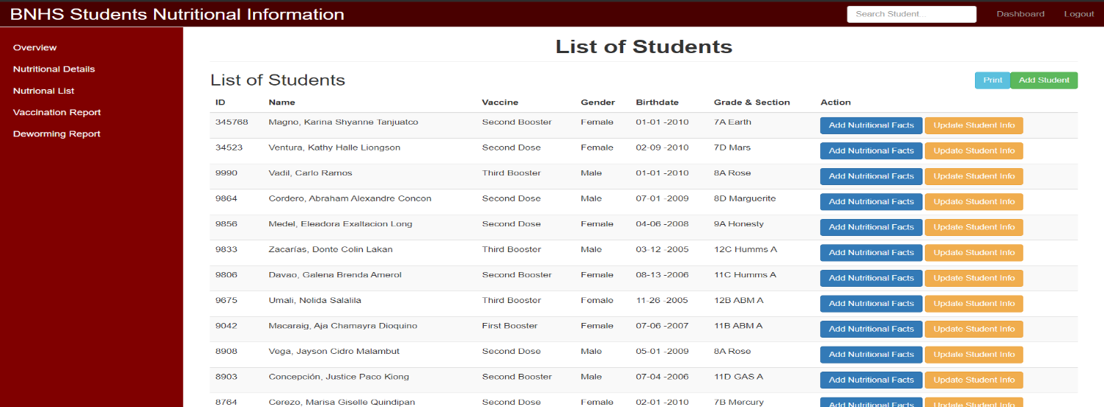been registered.

*Figure 5.2.* Reports (Nutritional Details)

**Overview-** The overview function returns to the main clinic dashboard.

**Nutritional Details-** This function shows the List of student patients where you can add their nutritional status and also update their information.

**Nutritional Lists.** This function shows the List of student patient’s Nutritional status Reports.

**Add Student-** This function let the user add a student patient to the list.

**Add Nutritional Facts-**This function let the user add the nutritional details of the patient.

**Update Student Info-** This function let the user update and edit the student patient’s information.

**Dashboard-** This function servers as the main button to go back to the Nutritional details.

**View Site-** This function servers as the main button to go back to the Clinic main Dashboard.

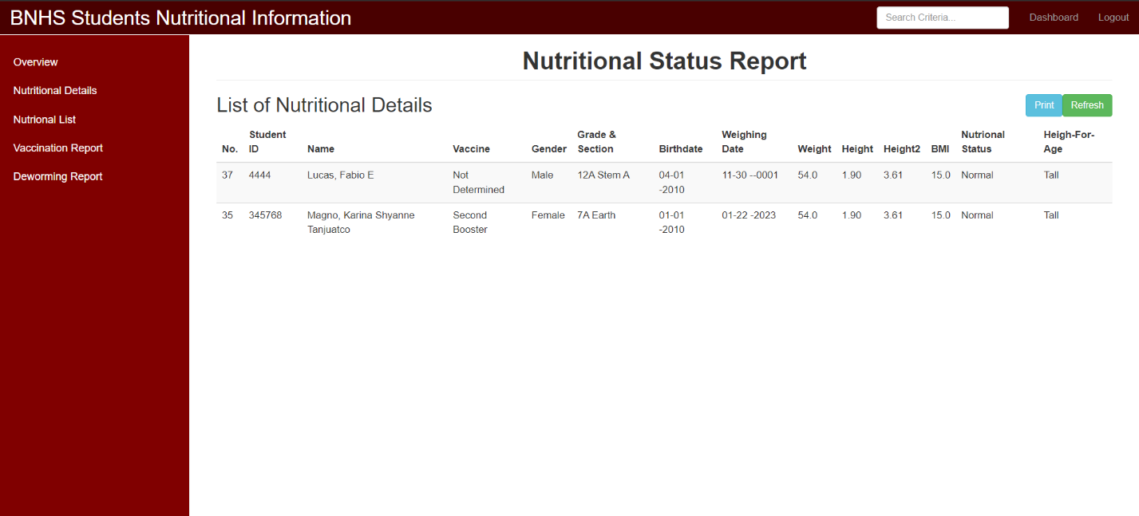**Logout-** This function will terminate the user’s session in the system and return to the login page of the system.

*Figure 5.3.* Nutritional List

**Nutritional Lists-** This function will show the List of student patient’s Nutritional status Reports.

**Print**- This Function will let the user print the list of report.

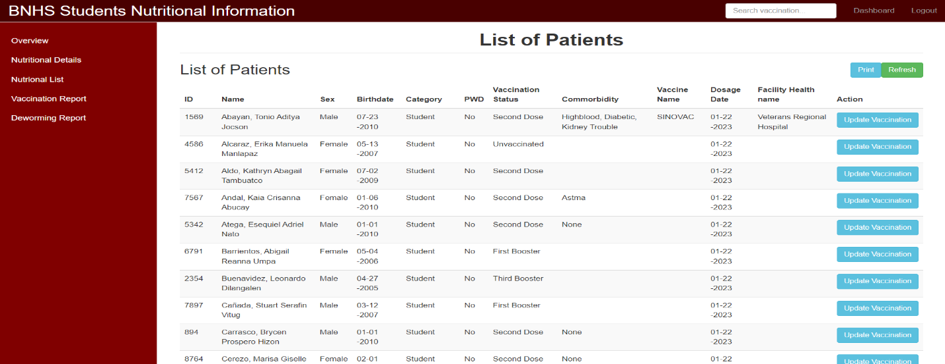**Refresh**- This function allows the user to reload the report list of patients.

*Figure 5.4.* Vaccination Report

**Print**- This function let the user print the list of report.

**Refresh**- This function allows the user to reload the report list of patients.

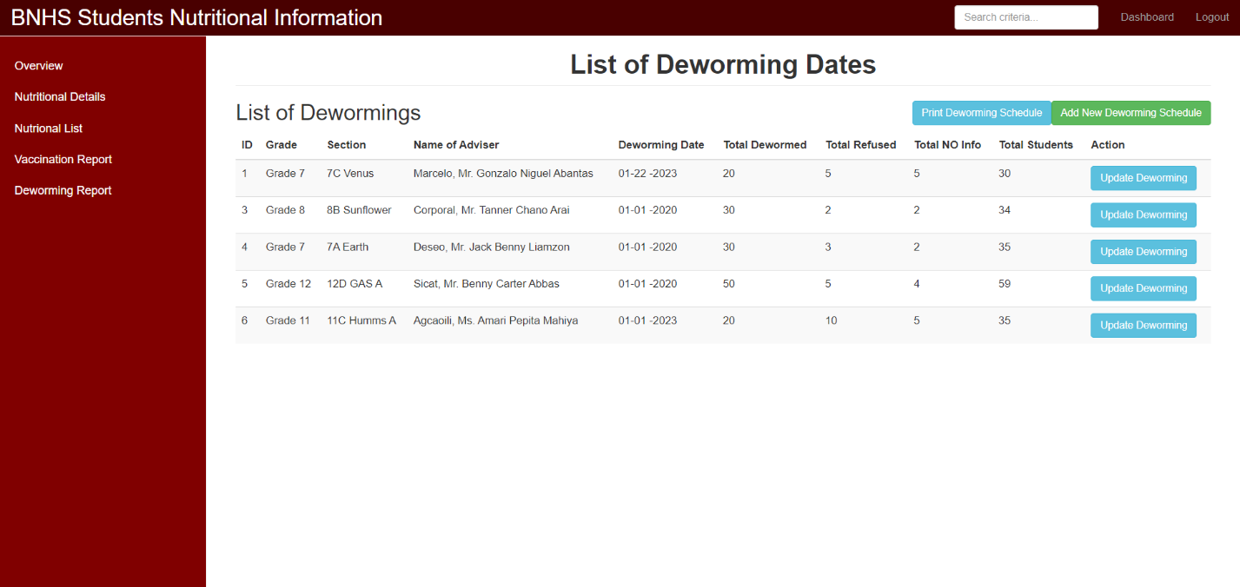**Update Vaccination-** This function allows the user update and edit patient’s vaccination details.

*Figure 5.5.* Deworming Report

**Print Deworming Schedule-** This function let the user print the deworming schedule report.

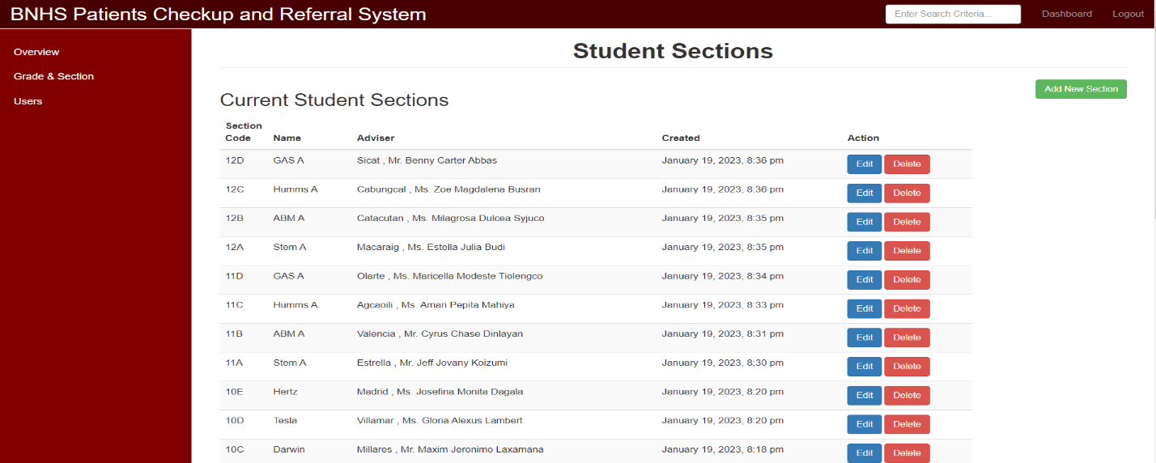**Add New Deworming Schedule-** This function let the user add the Deworming Schedule of a section.

*Figure 5.6.* Settings (Grade and Section)

**Add New Section-** This function will let the user add new section details.

**Edit-** This function will let the user edit the section details.

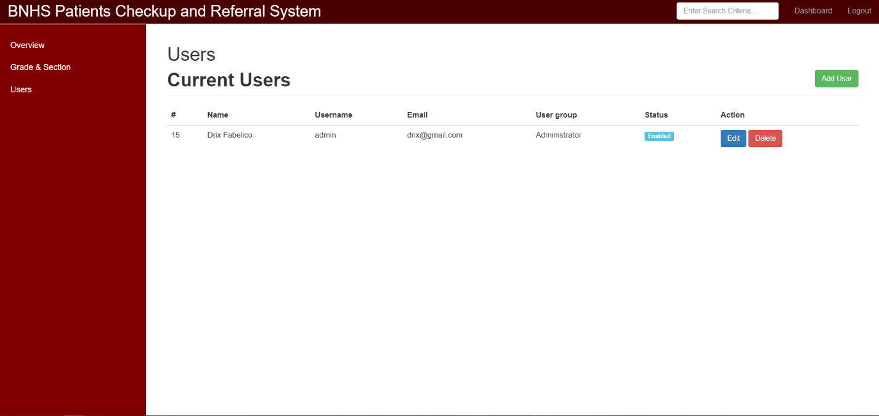**Delete-** This function will let the user delete the selected section.

*Figure 5.7.* Settings (Users)

**Add User-** This Function will let the user add new authorized user that can access the system.

**Edit-** This Function will let the user edit the user’s details.

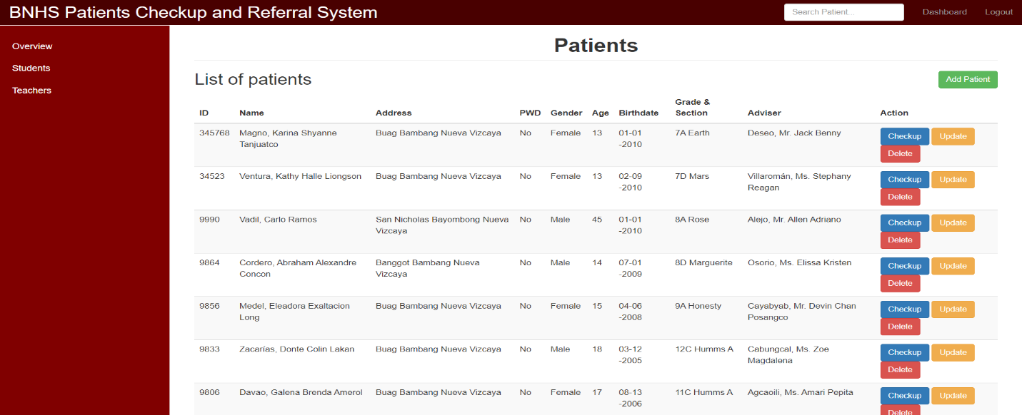**Delete-** This Function will let the user delete the selected user’s details and account.

*Figure 5.8.* Student Patient List

**Students-** This function will show the list of student patients in the system.

**Add Patient-** This Function will let the user add a new student patient to the system.

**Checkup-** This function let the user add check-up details to the student patient for their medical history.

**Update -** This Function will let the user update the details and information of the student patient.

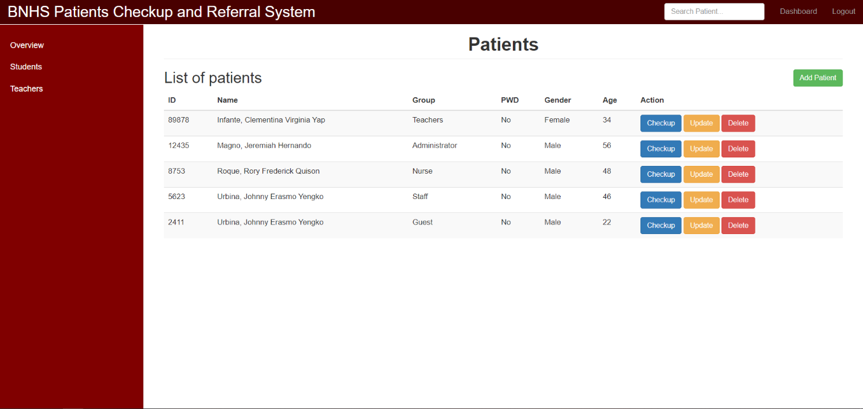**Delete-** This Function will let the user delete the selected patient’s entire details and account

*Figure 5.9.* Teacher Patient List

**Teachers-** This function shows the list of teacher or staff patients in the system.

**Add Patient-** This function let the user add a new teacher patient to the system.

**Checkup-** This function let the user add check-up details to the teacher patient for their medical history.

**Update -** This function let the user update the details and information of the teacher patient.

**Delete-** This function will let the user delete the selected patient’s entire details and account

**CHAPTER IV**

**SUMMARY FINDINGS AND RECOMMENDATIONS**

**Summary Findings**

**Table 6.** Summary on the Extent of Compliance of the Proposed System of ISO 25010:2015 Software quality standard per dimensions.

|  |  |  |  |
| --- | --- | --- | --- |
|  | **Mean** | **Developmental Equivalence** | **Interpretation** |
| 1. **Functional Suitability** | 4.50 | Outstanding or very great extent | Very High degree of compliance |
| 1. **Functional Suitability** | 4.58 | Outstanding or very great extent | Very High degree of compliance |
| 1. **Compatibility** | 4.75 | Outstanding or very great extent | Very High degree of compliance |
| 1. **Usability** | 4.54 | Outstanding or very great extent | Very High degree of compliance |
| 1. **Reliability** | 4.38 | Very Satisfactory or great extent | High degree of compliance |
| 1. **Security** | 4.65 | Very Satisfactory or great extent | High degree of compliance |
| 1. **Maintainability** | 4.75 | Very Satisfactory or great extent | High degree of compliance |
| 1. **Portability** | 5.00 | Very Satisfactory or great extent | High degree of compliance |
| ***OVERALL*** | ***4.63*** | ***Very Satisfactory or great extent*** | ***High degree of compliance*** |

**Recommendation**

With the conclusion discussed above, the following recommendations are suggested:

1. That the future researchers will integrate the system registration of student profile in the internet for fast and less hustle data gathering of information.
2. That the future researchers will use this study as a basis to help promote the clinic medical management system to other Dep-Ed schools.

**APPENDIX A**

Inform Consent Form

**Informed Consent Form**

This form is for students in the School of Engineering, Architecture and Information Technology in their participation to the research project entitled Web-Based Medical Record Management of Bambang National High School

Name of Researchers: Fabelico, Fitzfedrix E.

Olpindo, Brent Joshua A.

Organizational Affiliation: Saint Mary’s University School of Engineering, Architecture and Information Technology

Department of Information Technology

**Information Sheet**

You are being invited by student researchers from Saint Mary’s University to participate in their study on the development of a Web Based Medical Record System of Bambang National High School. You can take your time to decide whether to participate or not and you can ask questions any time for any word or concept in this form that you may not understand.

The purpose of this study is to develop a Web Based Medical Record System of Bambang National High School to enhance the existing processes and practices of the school clinic.

This study involves the use of direct interview that respondents will answer in-person. You are selected as participant because you are part of the school of Bambang National High School. You are one among the 2 selected clinic staff of Bambang National High School. Please be informed that your participation is voluntary, and you can withdraw any time without explanation. Your non-participation or withdrawal will not affect your reputation as a student or faculty of the school.

Should you choose to participate in the study, you shall be participating in an interview.

It is estimated that your participation in the study will only take not more than 15 minutes.

There is no known risk in your participation to the study.

However, you will be contributing to the development of the system as a result of this study and this may be beneficial to The School Clinic of Bambang National High School.

You shall not receive any payment for your participation nor any reimbursements. Even if you have chosen to participate voluntarily, you have the right to refuse to continue and any information you have already provided will not be used in the study. Rest assured that your privacy will be respected, and all your answers will be treated with utmost confidentiality.

The results of this study may be disseminated within Saint Mary’s University through student research form. Also, the study may be submitted for publication in national or international journals. For any matter concerning this study, you can contact Drix Fabelico through the following mobile number: 09533005300 or email: drixzfabelico@gmail.com

This study is approved by the Saint Mary’s University Research Ethics Board (SMUREB) at Saint Mary’s University, Ponce Street, DMM, Bayombong, Nueva Vizcaya with cellphone number: 09177053041 and email: [reb@smu.edu.ph](mailto:reb@smu.edu.ph).

**Certificate of Consent**

I have read the foregoing information, or it has been read to me. I have had the opportunity to ask questions about it and any questions I have asked have been answered to my satisfaction. I consent voluntarily to be a participant in this study.

Print Name of Participant: ___________________

Signature of Participant: ________________________

Date:

I have accurately read out the information sheet to the potential participant, and to the best of my ability made sure that the participant understands that the following will be done:

* I agree to participate in the study
* I disagree to participate in the study

I confirm that the participant has been given the opportunity to ask questions and all his/her queries have been answered correctly to the best of my ability. I confirm that the individual has not been coerced into giving consent, and the consent has been given freely and voluntarily.

NAME and SIGNATURE______________________

DATE______________________

**APPENDIX B**

Interview Questionnaire

**DETAILED INTERVIEW**

**Demographics/Profile of School Nurse/Heath Worker**

1. Name: (What is your name?) __________________
2. Age: (How old are you?) ______________________
3. Length of Service: (How long have you been working in BNHS?) _______________
4. Job Description: (What is/are your functions and responsibilities in this school?) _______________________________________________________________________________________________________________________________________________________________________________________________________________

**Existing Practices and Process of School Clinic**

1. What are the existing practices and processes of the school clinic? ____________________________________________________________________________________________________________________________________________________________________________________________________________________________________________________________________________________
2. Are the students required to register or have their own clinic medical record when they enroll? _________________________________________________________________________________________________________________________________________________________________________________________________________________
3. Where are you keeping the medical records? How do you manage these medical records? _______________________________________________________________________________________________________________________________________________________________________________________________________________
4. How do you update the check-up records of your patients? _______________________________________________________________________________________________________________________________________________________________________________________________________________
5. How do your record and update the nutritional status and deworming records of your patients? _______________________________________________________________________________________________________________________________________________________________________________________________________________
6. How do you update the check-up records of your patients? _______________________________________________________________________________________________________________________________________________________________________________________________________________
7. How do you schedule appointments and check-up of your patients? _______________________________________________________________________________________________________________________________________________________________________________________________________________
8. How do you generate or produce patient’s reports to be submitted to the School Principal or to any concerned end-user? _______________________________________________________________________________________________________________________________________________________________________________________________________________
9. What practices are done in disposing of your medical records? How long do you keep your medical records? ______________________________________________________________________________________________________________________________________________________________________________________________________________________________________________________________________________________
10. What happen if emergency occurred? What are the practices done? _______________________________________________________________________________________________________________________________________________________________________________________________________________
11. Do the school use or have a LAN connection? What offices use these LAN? Who is the administrator of this LAN? ______________________________________________________________________________________________________________________________________________________________________________________________________________

**Problems and Challenges Encountered in the Existing Practices and Processes in the School Clinic**

1. What are the problems and challenges encountered in the existing practices and processes of the school clinic? ____________________________________________________________________________________________________________________________________________________________________________________________________________________________________________________________________________________
2. What are the problems or challenges that you experience in recording the medical information of your patients? How did you manage to solve this problem? ________________________________________________________________________________________________________________________________________________________________________________________________________________
3. What are the problems or challenges that you experience in updating the check-up records of your patients? How did you manage to solve this problem? ________________________________________________________________________________________________________________________________________________________________________________________________________________
4. What are the problems or challenges that you experience in recording and updating the nutritional status and deworming records of your patients? How did you manage to solve this problem? ____________________________________________________________________________________________________________________________________________________________________________________________________________
5. What are the problems or challenges that you experience in updating the check-up records of your patients? How did you manage to solve this problem? _________________________________________________________________________________________________________________________________________________________________________________________________________________
6. What are the problems or challenges that you experience in scheduling appointments and check-up of your patients? How did you manage to solve this problem? _________________________________________________________________________________________________________________________________________________________________________________________________________________
7. What are the problems or challenges that you experience in generating or producing patient’s reports to be submitted to the School Principal or to any concerned end-user? How did you manage to solve this problem? _________________________________________________________________________________________________________________________________________________________________________________________________________________

**Proposal for the Development of Web-based Medical Record Management System**

1. Do you want to improve your medical record management system? _____________________________________________________________________
2. Would you like to have a medical record management system of BNHS linked to your LAN? _____________________________________________________________________
3. What are your suggestions to improve your medical record management system in your clinic? ________________________________________________________________________________________________________________________________________________________________________________________________________________________________________________________________________________________

**APPENDIX C**

Evaluation Form

EVALUATION FORM

A ProposedWeb Based Medical Record Management System of Bambang National High School EVALUATION using ISO/IEC 25010 Software Quality Standards

*(This survey questionnaire is designed to determine the status and performance of the A Proposed* Web-Based Medical Record Management System of Bambang National High School*)*

Dear Respondent,

We are currently undertaking our Capstone Project which is A Proposed Web Based Medical Record Management System of Bambang National High School. With this, we respectfully ask for your help in giving the information requested below for assessment reasons. The information will be very helpful for us as we finish our final capstone project paper and complete the prerequisites for the Bachelor of Science in Information Technology degree.

Thank you very much.

Fabelico, Fitzfedrix E.

Olpindo, Brent Joshua A.

Please check the box that best represents your assessment on the extent of compliance to ISO 25010:2015 of the developed Web based medical record system of Bambang National High School in terms of Functionality, Efficiency, Usability, Reliability, Portability, and Maintainability and using the following scale:

5 – Outstanding or to a very great extent

4 – Very Satisfactory or to a great extent

3 – Satisfactory or to a moderate extent

2 – Fair or to a little extent

1 – Poor or to a very little extent

|  |  |  |  |  |  |
| --- | --- | --- | --- | --- | --- |
| **ISO 25010 Software Quality Standards** | **5** | **4** | **3** | **2** | **1** |
| 1. **Functional Suitability** | **5** | **4** | **3** | **2** | **1** |
| Functional completeness  It covers all the specified tasks and user objectives |  |  |  |  |  |
| Functional correctness  It provides the correct results with the needed degree of precision |  |  |  |  |  |
| Functional appropriateness  Facilitate the accomplishment of specified tasks and objectives |  |  |  |  |  |
| 1. **Performance Efficiency** | **5** | **4** | **3** | **2** | **1** |
| Time behavior  Meet the requirements in the response and processing time when performing its functions |  |  |  |  |  |
| Resource utilization  Meet the requirements in the amounts and types of resources used when performing its functions |  |  |  |  |  |
| Capacity  Meet the requirements in the maximum limits |  |  |  |  |  |
| 1. **Compatibility** | **5** | **4** | **3** | **2** | **1** |
| Co-existence  Can perform its required functions efficiently while sharing a common environment and resources |  |  |  |  |  |

|  |  |  |  |  |  |
| --- | --- | --- | --- | --- | --- |
| Interoperability  Components can exchange information and use the information that has been exchanged |  |  |  |  |  |
| 1. **Usability** | **5** | **4** | **3** | **2** | **1** |
| Appropriateness recognizability  It is appropriate to the needs of the users. |  |  |  |  |  |
| Learnability  Can be used to achieve specified goals of learning with effectiveness, efficiency, freedom from risk and satisfaction in a specified context of use |  |  |  |  |  |
| Operability  It is easy to operate and control |  |  |  |  |  |
| User error protection  Protects users against making errors |  |  |  |  |  |
| User interface aesthetics  Its interface enables pleasing and satisfying interaction for the user |  |  |  |  |  |
| Accessibility  Can be used to a widest range of characteristics and capabilities to achieve a specified goal in a specified context of use |  |  |  |  |  |
| 1. **Reliability** | **5** | **4** | **3** | **2** | **1** |
| Maturity  Meets the need for reliability under normal operation |  |  |  |  |  |
| Availability  It is operational and accessible when required for use |  |  |  |  |  |
| Fault tolerance  It operates as intended despite the presence of hardware or software faults |  |  |  |  |  |

|  |  |  |  |  |  |
| --- | --- | --- | --- | --- | --- |
| Recoverability  Can recover the data directly affected and re-establish the desired state. |  |  |  |  |  |
| 1. **Security** | **5** | **4** | **3** | **2** | **1** |
| Confidentiality  Ensures that the data are accessible only to those authorized to have access |  |  |  |  |  |
| Integrity  Prevents unauthorized access to, or modification of programs or data |  |  |  |  |  |
| Non-repudiation  Can be proven to have taken place, so that it cannot be repudiated later |  |  |  |  |  |
| Accountability  Actions of an entity can be traced uniquely to the entity |  |  |  |  |  |
| Authenticity  The identity of a subject can be proved to be the one claimed |  |  |  |  |  |
| 1. **Maintainability** | **5** | **4** | **3** | **2** | **1** |
| Modularity  Composed of discrete components such that a change to one component has minimal impact on other components |  |  |  |  |  |
| Reusability  Assets can be used in more than one system, or in building other assets |  |  |  |  |  |
| Analyzability  It is possible to assess the impact of an intended change to one or more of its parts, or to diagnose deficiencies or cause of failures |  |  |  |  |  |
| Modifiability  Can be effectively and efficiently modified without introducing defects or degrading existing product quality |  |  |  |  |  |
| Testability  Test Criteria can be established and can be performed to determine whether those criteria have been met |  |  |  |  |  |
| 1. **Portability** | **5** | **4** | **3** | **2** | **1** |
| Adaptability  Effectively and efficiently be adapted for evolving hardware, software, or other usage environments |  |  |  |  |  |
| Install ability  Can be successfully installed and/or uninstalled in a specified environment |  |  |  |  |  |
| Replaceability  Can replace another specified software product for the same purpose in the same environment. |  |  |  |  |  |

System Enhancement: Question:

What are your suggestions and comments to further enhance the proposed system?

___________________________________________________________________________________________________________________________________________________________________________________________________________________________________________________________________________________

**APPENDIX D**

Prototypes

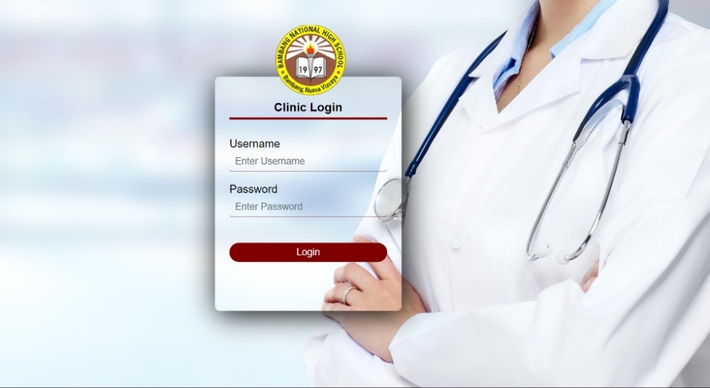

*Figure 6.* Login Page

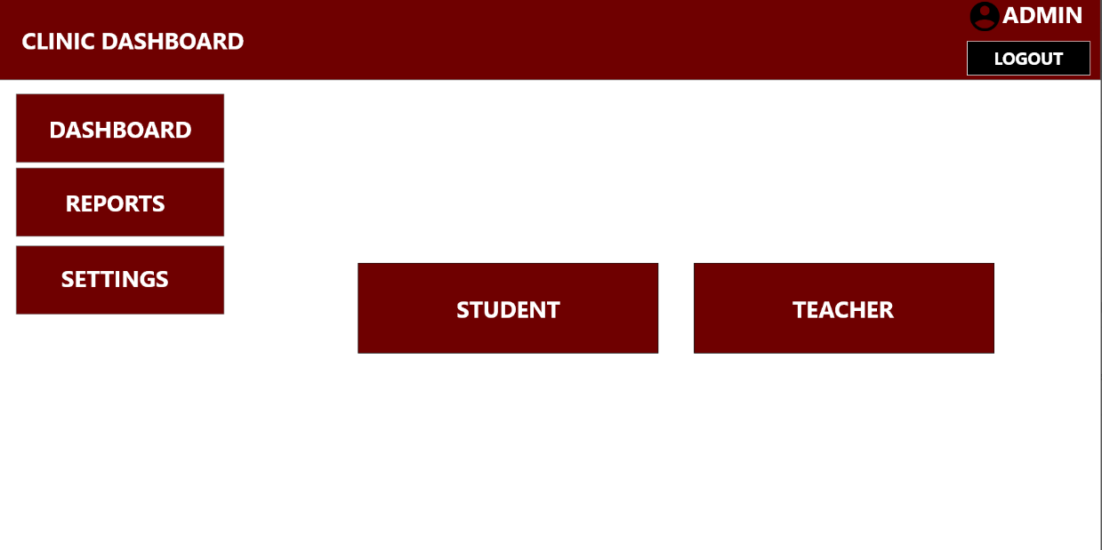

*Figure 6.1.* Clinic Dashboard

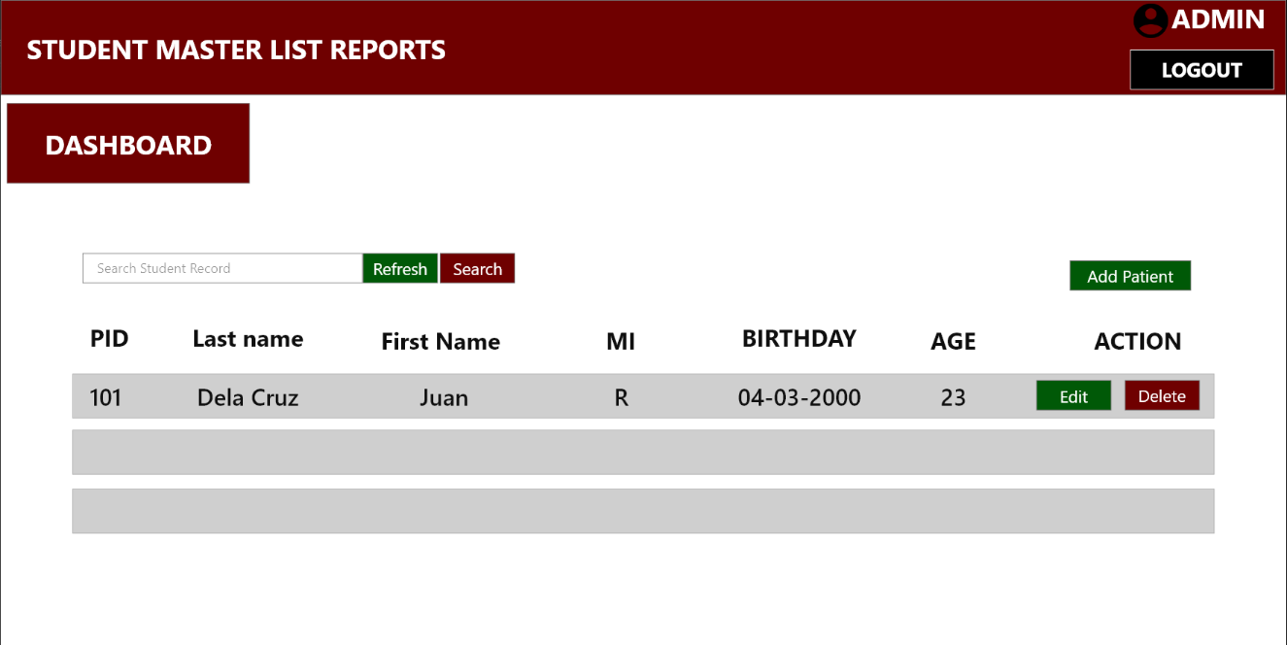

*Figure 6.2.* Reports

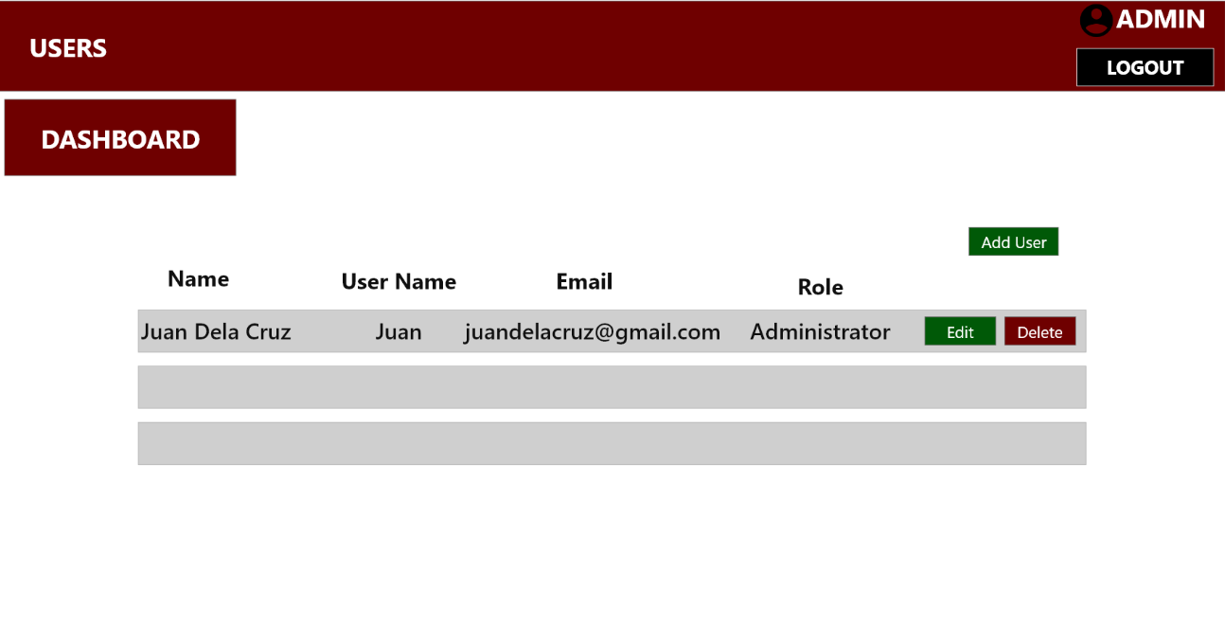

*Figure 6.3.* Users

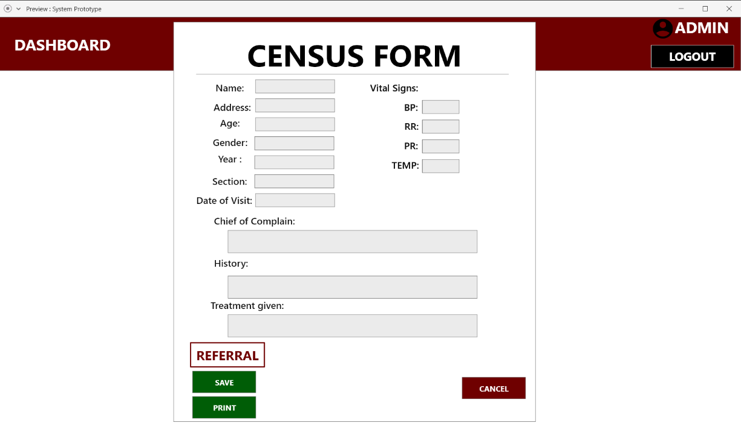*Figure 6.4.* Medical Form

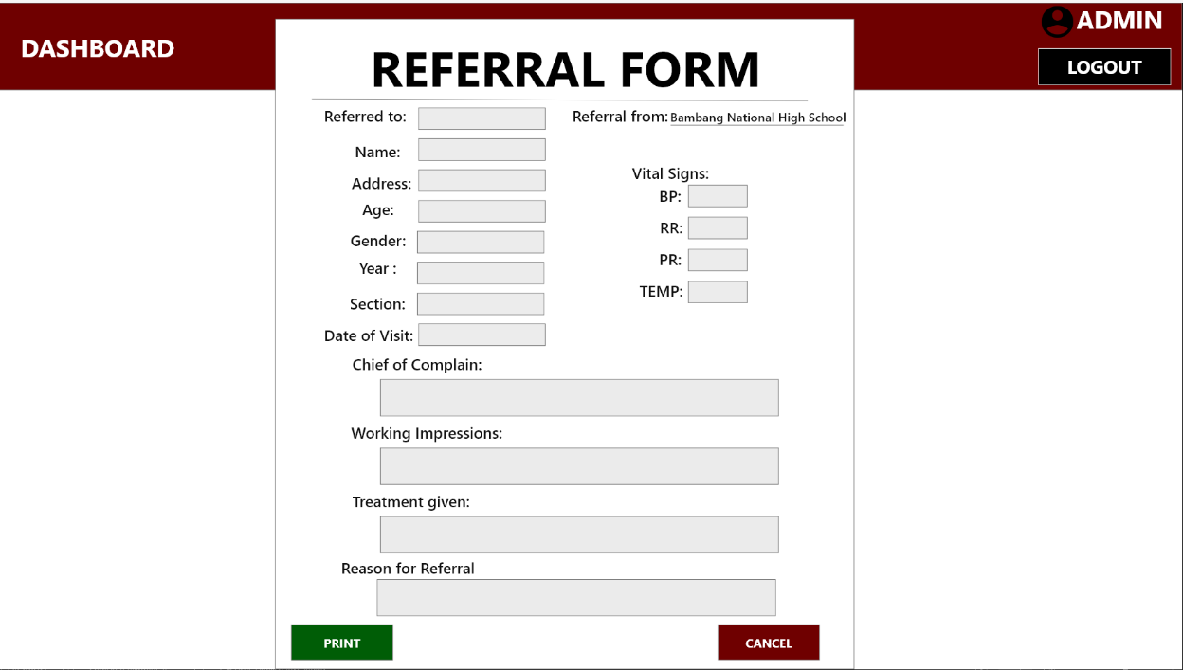

*Figure 6.5.* Referral Form

**Appendix E**

Answered Interview Questions

**MINUTES OF INTERVIEW**

**DETAILED INTERVIEW**

**Demographics/Profile of School Nurse/Heath Worker**

1. Name: (What is your name?) Glenda C. Martinez
2. Age: (How old are you?) 46 years old
3. Length of Service: (How long have you been working in BNHS?) 19 years
4. Job Description: (What is/are your functions and responsibilities in this school?)

School Nurse Designated at Junior High School (JHS)

Provide First aid care and health assessment to teacher, staff and students.

Communicate with teachers and staff and students to ensure safety and well-being of all

**Existing Practices and Process of School Clinic**

1. What are the existing practices and processes of the school clinic?

Advisers and subject teachers endorse students who are in need of medical assessments and are given first aid treatment and or referral for further examinations to RHU and Hospitals

1. Are the students required to register or have their own clinic medical record when they enroll? NO
2. Where are you keeping the medical records? How do you manage these medical records? Medical records are kept at school clinic cabinets and these records are store in folders and are arranged per grade and section
3. How do you update the check-up records of your patients?

Check-up records are not strictly monitored due to lack of systematic procedures in our school. Only students who are endorsed by adviser/teachers are monitored

1. How do your record and update the nutritional status and deworming records of your patients? Nutritional Status and Deworming records are recorded properly. DepEd provides templates for our reports for nutritional status and they are being assessed accordingly. Students who are severely wasted are given priority for feeding program
2. How do you update the check-up records of your patients?

We lack records for these

1. How do you schedule appointments and check-up of your patients?

Only referred students are given assessments

1. How do you generate or produce patient’s reports to be submitted to the School Principal or to any concerned end-user?

Reports are consolidated by the nurse on which advisers are required to submit to their respective curriculum chair

1. What practices are done in disposing of your medical records? How long do you keep your medical records?

Medical records are kept as long as the student is enrolled on the school.

1. What happen if emergency occurred? What are the practices done?

We have our first aid kits and nurses and DRRM officers were trained to conduct/give first aid treatment and patients are directly referred to nearby hospital/RHU.

1. Do the school use or have a LAN connection? What offices use these LAN? Who is the administrator of this LAN?

The school have Lan connection which uses wifi routers. The routers are located every offices in the campus.

**Problems and Challenges Encountered in the Existing Practices and Processes in the School Clinic**

1. What are the problems and challenges encountered in the existing practices and processes of the school clinic?

Our school only designate nurses who are also teachers that cannot function as full time school nurses. Records were not organized and we lack facilities as well.

1. What are the problems or challenges that you experience in recording the medical information of your patients? How did you manage to solve this problem?

Due to increasing number of students and we do not have a system that may keep our records updated and faster, we cannot come up with student’s medical record.

1. What are the problems or challenges that you experience in updating the check-up records of your patients? How did you manage to solve this problem?

Duplication of records (manual filing).

We will check if there is an existing record of student which takes time.

1. What are the problems or challenges that you experience in recording and updating the nutritional status and deworming records of your patients? How did you manage to solve this problem?

Nutritional Status are well recorded because MAPEH teachers are the one taking records and are submitted to the division office on time.

1. What are the problems or challenges that you experience in scheduling appointments and check-up of your patients? How did you manage to solve this problem?

No full time school nurses.

1. What are the problems or challenges that you experience in generating or producing patient’s reports to be submitted to the School Principal or to any concerned end-user? How did you manage to solve this problem?

Records from adviser/teachers may sometimes late in submitting reports or non at all.

**Proposal for the Development of Web-based Medical Record Management System**

1. Do you want to improve your medical record management system?

YES.

1. Would you like to have a medical record management system of BNHS linked to your LAN?

YES.

1. What are your suggestions to improve your medical record management system in your clinic?

-Computer set/laptop must be provided to school clinic.

-Program that may enhance record keeping as well as for updating medical records will be provided.

**Appendix F**

Observation

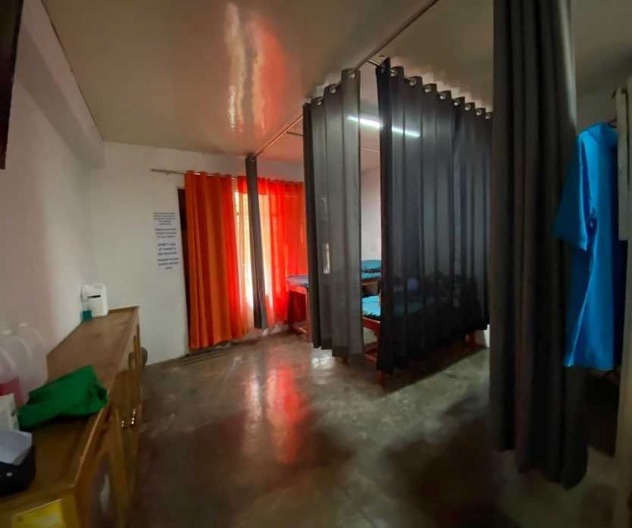

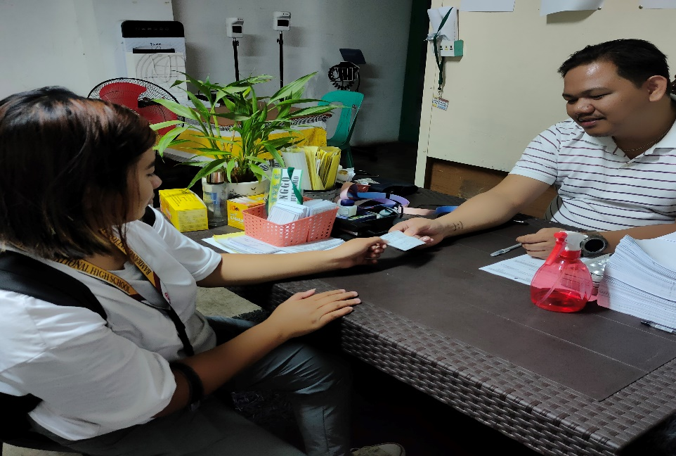

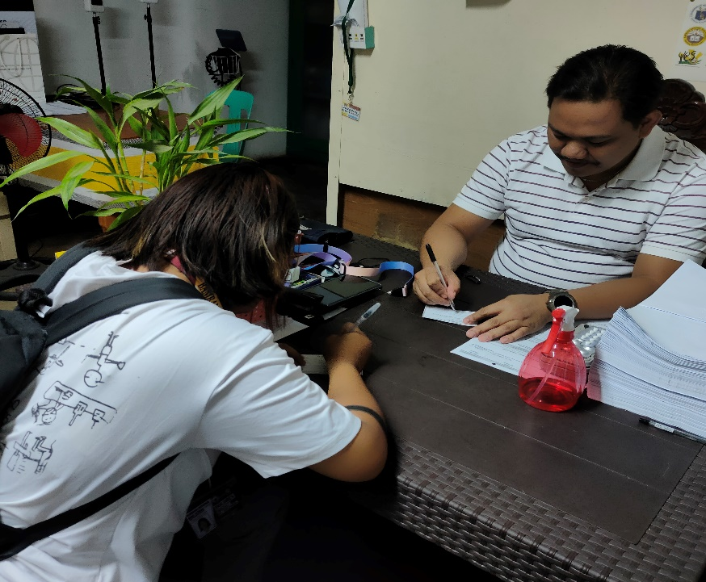

*Figure 3.* Observation

**APPENDIX G**

Interview with the School Nurse

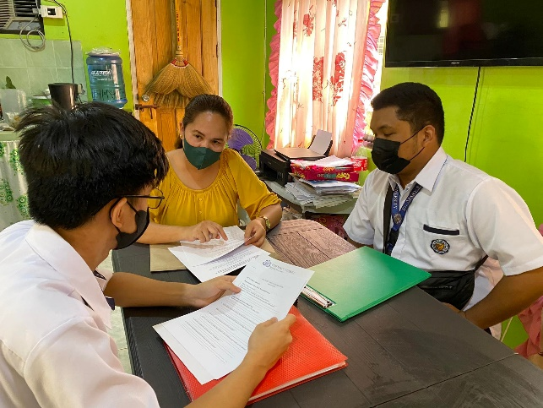

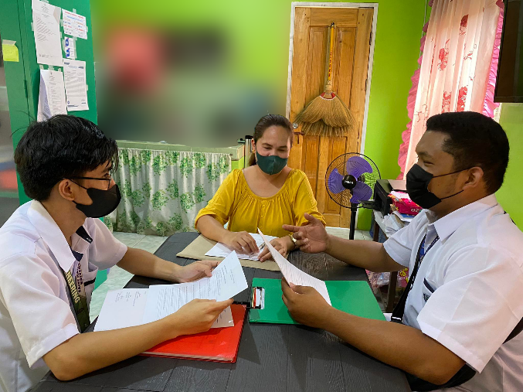

*Figure 4.* Interview with school nurse

**APPENDIX H**

Document Review

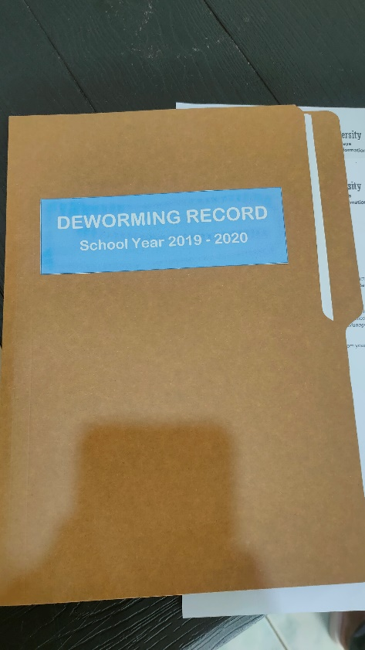

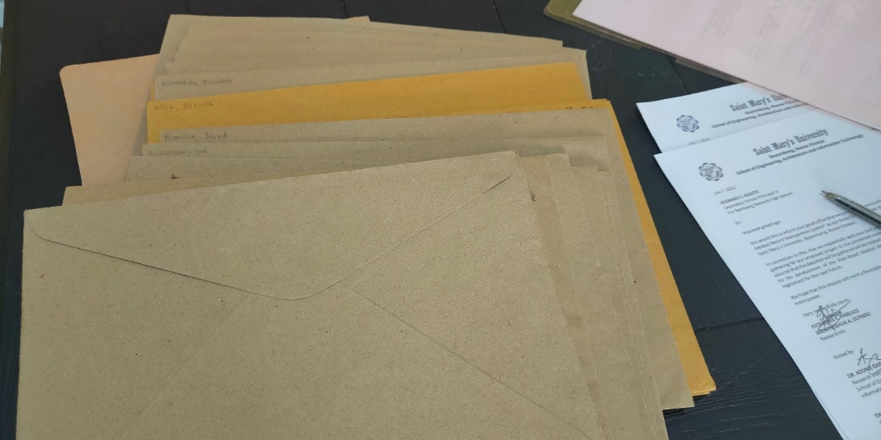

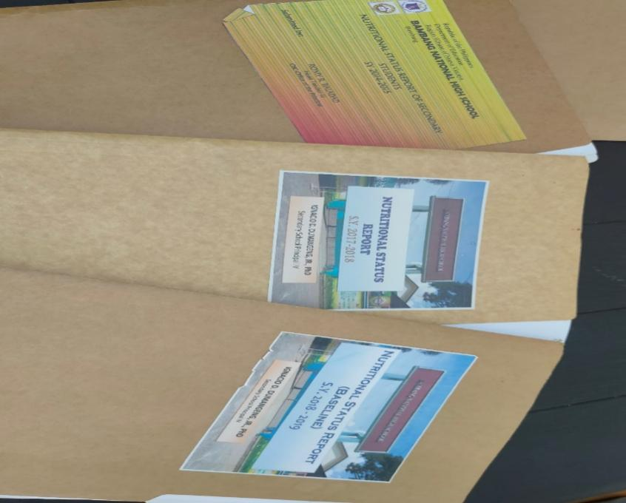

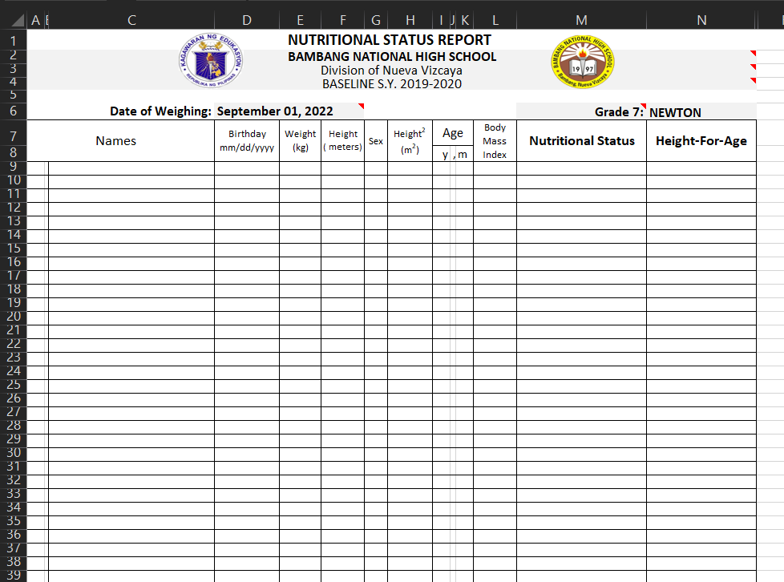

*Figure 5.* Document Review

**APPENDIX I**

Implementation Plan

**Implementation Plan**

1. **Management Overview**

The system's primary responsibility is to manage and arrange the clinic medical record system at Bambang National High School, apply the system to users accurately, and instruct users on how to use it correctly.

**Point of Contact**

|  |  |  |
| --- | --- | --- |
| **Role** | **Name** | **Contact Number** |
| Developer | Fitzfedrix Fabelico | 09533005300 |
| Brent Joshua Olpindo |  |

1. **Implementation Support**

|  |  |
| --- | --- |
| **Platform** | **Description** |
| **Desktop** | * Processor: Intel Core i3 or greater * Memory: 4GB RAM or higher * Hard Disk Space: 1TB * Monitor:14” LCD * Keyboard:101/102 Keyboard * Mouse: Microsoft USB * Printer: Epson 2100 |

1. **Hardware**
2. **Software**

|  |  |
| --- | --- |
| **Platform** | **Description** |
| **Desktop** | * Operating System: Windows 7 or greater * Database Application: MySQL (SQLyog v.10) * Software Development: Visual Studio Code |

**REFERENCES**

Acacio-Claro, P. J., Estuar, M. R. J., Villamor, D. A., Bautista, M. C., Sugon Jr, Q., & Pulmano, C. (2022). A Micro-analysis Approach in Understanding Electronic Medical Record Usage in Rural Communities: Comparison of Frequency of Use on Performance Before and During the COVID-19 Pandemic.

Toquero, C. M. (2020). Challenges and opportunities for higher education amid the COVID-19 Pandemic: The Philippines Context. Pedagogical Research, 5(4), em0063

Simbulan, N. (2020). COVID-19 and its impact on higher education in the Philippines. *Higher education in Southeast Asia and Beyond*, *8*, 15-18.

Almacen, A. M. B., & Cabaluna, A. Y. (2021). Electronic Document Management System (EDMS) Implementation: Implications for the Future of Digital Transformation in Philippine Healthcare. *Journal of Computer Science and Technology Studies*, *3*(2), 82-90.

Shahmoradi, L., Darrudi, A., Arji, G., & Ahmadreza, F. N. (2017). Electronic health record implementation: *A SWOT analysis. Acta Medica Iranica, 55*(10), 642-649.

http://acta.tums.ac.ir

Reeves, J. J., Pageler, N. M., Wick, E. C., Melton, G. B., Tan, Y. H. G., Clay, B. J., & Longhurst, C. A. (2021). The clinical information systems response to the COVID-19 pandemic. *Yearbook of medical informatics*, *30*(01), 105-125.

<https://www.thieme-connect.com/products/ejournals/html/10.1055/s-0041-1726513>

Williams B., (2022). BENEFITS FROM ELECTRONIC MEDICAL RECORD SYSTEMS ADOPTION AND USE IN SMALL HOSPITALS.

<https://www.proquest.com/openview/52ffeacdc185fe6b0c696a972a5302d9/1?pq-origsite=gscholar&cbl=18750&diss=y>

Tergundi, P., Baliga, P., Kamble, N., Patil, P., & Raval, N. (2017). Web based Clinical Data Management System. International Journal of Advanced Research in Computer and Communication Engineering, 6, 314-319.

<https://doi.org/10.17148/IJARCCE.2017.6655>

Mashoka, R.J. et al. (2019) ‘Implementation of electronic medical records at an Emergency Medicine Department in Tanzania: The information

Nuyanti & Widayanti,N.A.(2015). Evaluation of implementation of electronic health record (EHR) system at academic hospital Gadjah Mada University based on pieces analysis method

Agu, E.O., Nwadialor, G.O., and Moses, T. (2016). Design and Implementation of a Dynamically Adapted Students’ Admission System: African Journal of Education, Science and Technology Vol 3, 162-179

Adebisi, O.A, Oladosu, D.A, Busari, O.A and Oyewola, Y.V. 2015. Design and Implementation of Hospital Management System: *International Journal of Engineering and Innovative Technology Volume 5(1)*

Jibrin M. , Salisu G. (2019). Web-based Clinic Management System (CMS)

<https://www.academia.edu/52315250/Web_based_Clinic_Management_System_CMS_>

F. Fatima , M. Javed, F. Amjad and U. G. Khan, "An Approach to Enhance Quality of The Rad Model Using Agents," The International Journal of Science and Technoledge, vol. 2, no. 13, pp. 202-210, December 2014.

M. L. Despa, "Comparative Study on Software Development Methodologies," Database Systems Journal, vol. Vol V No. 3, pp. 37-56, 2014.

Delima, R., Santosa, H. B., & Purwadi, J. (2017). Development of Dutatani Website Using Rapid Application Development. *IJITEE (International Journal of Information Technology and Electrical Engineering)*, *1*(2), 36-44. <https://journal.ugm.ac.id/ijitee/article/view/28362>

W. W. Widiyanto, “Analisa Metodologi Pengembangan Sistem Dengan Perbandingan Model Perangkat Lunak Sistem Informasi Kepegawaian Menggunakan Waterfall Development Model, Model Prototype, Dan Model Rapid Application Development (Rad),” *J. Inf. Politek. Indonusa Surakarta*, vol. 4, no. 1, pp. 34–40, 2018, [Online]. Available: <http://www.informa.poltekindonusa.ac.id/index.php/informa/article/view/34>

Pratiwi, M., Mayola, L., Laoli, V. K. H., Arsyah, U. I., & Pratiwi, N. (2022). Medical Record Information System with Rapid Application Development (RAD) Method. *Journal of Information Systems and Technology Research*, *1*(2), 124-130.

Ismail, A., Kadir, S.A., Aziz, A.A., Mokhsin, M.B., & Lokman, A.M. (2016). iTourism Travel Buddy Mobile Application. 2016 10th International Conference on Next Generation Mobile Applications, Security and Technologies (NGMAST), 82-87.

H. Kusmiati and M. Ansori, “Penerapan Rapid Application Development Pada Aplikasi Pencabutan Layanan Reguler Smart PT. PLN (Persero),” *J. Ilm. SISFOTENIKA*, vol. 5, no. 2, pp. 107–118, 2015.

M. Hasanudin, H. M. Khoirudin, W. A. Amroni, and S. Silen, “Aplikasi E-Commerce Sistem Informasi Penjualan Rolling Door Berbasis Rapid Application Development,” *J. PETIR*, vol. 12, no. 1, 2019, doi: 10.33322/petir.v12i1.368.

D. Irfan, R. Melyanti, S. Tuanku Tambusai Pasir Pangaraian, U. Negeri Padang, and S. Hang Tuah Pekanbaru, “Sistem Informasi Pelanggaran Siswa Berbasis Web Menggunakan Rapid Application Development Web-Based Student Violation Information System Using Rapid Application Development,” *J. Inf. Technol. Comput. Sci.*, vol. 3, no. 2, pp. 234–242, 2020.

M. Y. Putra and R. W. R. Lolly, “Sistem Aplikasi Penjualan Souvenir Berbasis Web Menggunakan Metode Rapid Application Development (RAD),” *Inf. Syst. Educ. Prof.*, vol. 5, no. 2, pp. 1–10, 2021.

I. D. Sintawati, “Pembuatan Sistem Informasi Penjualan Kue Berbasis Web Dengan Metode RAD (Rapid Application Development),” *J. Inf. Syst. Applied, Manag. Account. Res.*, vol. 2, no. 4, pp. 1–6, 2018.

A.Suryanto and M. I. Maliki, “Penerapan Model Rapid Application Development (RAD) Dalam Rancang Bangun Sistem Informasi Warga,” *Infotek J. Inform. dan Teknol.*, vol. 5, no. 1, pp. 197–208, 2022, doi: 10.29408/jit.v5i1.4887.

Muhammad, J., & Garba, S. (2019). Web-based Clinic Management System (CMS). *International Journal of Science and Engineering Applications*, *8*(05), 131-135.

Richey, R. C., & Klein, J. D. (2005). Developmental research methods: Creating knowledge from instructional design and development practice. *Journal of Computing in higher Education*, *16*(2), 23-38.

A. Suryanto and M. I. Maliki, “Penerapan Model Rapid Application Development (RAD) Dalam Rancang Bangun Sistem Informasi Warga,” *Infotek J. Inform. dan Teknol.*, vol. 5, no. 1, pp. 197–208, 2022, doi: 10.29408/jit.v5i1.4887

Tarkar P. (2020). Impact Of Covid-19 Pandemic On Education System. International Journal of Advanced Science and Technology. 29. 3812-3814.

[https://www.researchgate.net/profile/PeetiTarkar/publication/352647439_Impact_Of_Covid-19_Pandemic_On_Education_System/links/60d1e909299bf19b8d99d279/Impact-Of-Covid-19-Pandemic-On-Education-System.pdf](https://www.researchgate.net/profile/Preeti-Tarkar/publication/352647439_Impact_Of_Covid-19_Pandemic_On_Education_System/links/60d1e909299bf19b8d99d279/Impact-Of-Covid-19-Pandemic-On-Education-System.pdf)

Web-Based Application: What It Is, and Why You Should Use It. . Available from: <https://lvivity.com/web-based-applications>.

The Benefits of Web-Based Systems for Business. . Available from: <https://www.aezion.com/blogs/the-benefits-of-web-based-systems-for-business/>.

Bevan, N. 2010. Extending The Concept Of Satisfaction In ISO Standards. *2010 International Confer-ence on Kansei Engineering and Emotion Research* (Keer2010), Paris, March, 2-4.

Herrera, M., Moraga, M. A., Caballero, I., and Calero, C. 2010. Quality In Use Model For Web Portals (Qiuwep). In F. Daniel and F.M. Facca (Eds*.), ICWE 2010 Workshops, LNCS*: Vol. 6385, (pp. 91-101). Berlin Heidelberg: Springer-Verlag.

ISO/IEC 9126-1 2001. *Iso/Iec 9126: 2001: Software Engineering – Product Quality - Part 1: Qual-Ity Model*. Geneva: ISO

SO/IEC 25010 2011. ISO/IEC 25010:2011: Systems And Software Engineering – Systems And Soft-Ware Quality Requirements And Evaluation (Square) – System And Software Quality Models. Geneva: ISO

Hussain, Azham & Mkpojiogu, Emmanuel. (2015). An application of the ISO/IEC 25010standard in the quality-in-use assessment of an online health awareness system. Jurnal Teknologi. 77. 10.11113/jt.v77.6107.

Ang, H. K. (2015). *Clinic Management System (Rapid Clinic)* (Doctoral dissertation, UTAR).

**OFFICIAL CO-CURRICULAR TRANSCRIPT**



|  |
| --- |
| **Name: Fabelico, Fitzfedrix E.** |
| Address: Buag, Bambang, Nueva Vizcaya 3702 |
| Email address: drixzfabelico@gmail.com |
| Contact number: 09533005300 |

|  |  |
| --- | --- |
| **PERSONAL INFORMATION** | |
| Age: 22 | Date of Birth: June 4, 2000 |
| Civil Status: Single | Place of Birth: Bambang, Nueva Vizcaya |
| Religion: Roman Catholic | Father’s name: Fitzgerald L. Fabelico  Mother’s name: Livinia E. Fabelico |

**EDUCATIONAL BACKGROUND**

|  |  |  |  |  |
| --- | --- | --- | --- | --- |
|  | Name of school | | Date completed | |
| Tertiary | Saint Mary’s University, Bayombong, N.V. | | August 2018 – Current | |
| Secondary | Saint Mary’s University, Bayombong, N.V. | | August 2016 – May 2018 | |
| Elementary | Saint Catherine’s School, Bambang N.V. | | June 2006 – April 2012 | |
| **MARIAN CORE VALUES**  **EXCELLENCE** (It refers to academic/ scholastic accomplishments and involvement in non-academic activities wherein the students develop knowledge, competencies, and skills) | | | | |
| **Award** | | **Event / Competition** | | **Date** |
|  | |  | |  |

|  |  |  |
| --- | --- | --- |
| **Involvement** | **Seminar / Convention** | **Date** |
| Participant Network Security and Cryptography 11/20/19  Participant Y4IT (Youth for IT) 8/20/21  **INNOVATION** (It refers to creative output such as research papers, capstone projects, systems developed, and students’ involvement in literary, arts and visual performances) | | |

|  |  |  |
| --- | --- | --- |
| **COMMUNION** (It refers to students’ involvement in school and community activities and leadership / trainings attended / conducted) | | |
| 1. **SCHOOL INVOLVEMENT** | | |
| **Designation** | **Organization** | **Date** |
|  |  |  |
| 1. **LEADERSHIP TRAININGS/SEMINARS** | | |
| **Involvement** | **Seminar / Training** | **Date** |

|  |  |  |
| --- | --- | --- |
| **PASSION FOR CHRIST’S MISSION** (It refers to students’ involvement in spiritual and pastoral activities) | | |
| **Involvement** | **Event** | **Date** |
| Participant Year of the Youth 2019 2019  **TECHNICAL SKILLS / COMPETENCIES** | | |

* Basic Knowledge about Android Studio, Visual Studio and Adobe Xd.
* Basic Knowledge of WonderShare Filmora, Adobe PhotoShop, Video editing and Photo editing.
* Knowledgeable in SQL, Java, HTML and XML.

**OFFICIAL CO-CURRICULAR TRANSCRIPT**

|  |
| --- |
| **Name: Olpindo, Brent Joshua A.** |
| Bascaran, Solano, Nueva Vizcaya |
| Email address: brentolpindo@gmail.com |
| Contact number: 09503390225 |



|  |  |
| --- | --- |
| **PERSONAL INFORMATION** | |
| Age: 22 | Date of Birth: July 31, 2000 |
| Civil Status: Single | Place of Birth: Bayombong, Nueva Vizcaya |
| Religion: Roman Catholic | Father’s name: Jehova L. Olpindo  Mother’s name: Anna Liza A. Olpindo |

**EDUCATIONAL BACKGROUND**

|  |  |  |  |  |
| --- | --- | --- | --- | --- |
|  | Name of school | | Date completed | |
| Tertiary | Saint Mary’s University, Bayombong, N.V. | | August 2019 – Current | |
| Secondary | Saint Mary’s University, Bayombong, N.V. | | August 2016 – May 2018 | |
| Elementary | Isaiah Christian Academy, Solano, N.V. | | June 2006 – April 2012 | |
| **MARIAN CORE VALUES**  **EXCELLENCE** (It refers to academic/ scholastic accomplishments and involvement in non-academic activities wherein the students develop knowledge, competencies, and skills) | | | | |
| **Award** | | **Event / Competition** | | **Date** |
|  | |  | |  |

|  |  |  |
| --- | --- | --- |
| **Involvement** | **Seminar / Convention** | **Date** |
| **INNOVATION** (It refers to creative output such as research papers, capstone projects, systems developed, and students’ involvement in literary, arts and visual performances) | | |

|  |  |  |
| --- | --- | --- |
| **COMMUNION** (It refers to students’ involvement in school and community activities and leadership / trainings attended / conducted) | | |
| 1. **SCHOOL INVOLVEMENT** | | |
| **Designation**  Business Manager | **Organization**  MICRO | **Date**  S.Y. 2021-2022 |
|  |  |  |
| 1. **LEADERSHIP TRAININGS/SEMINARS** | | |
| **Involvement** | **Seminar / Training** | **Date** |

|  |  |  |
| --- | --- | --- |
| **PASSION FOR CHRIST’S MISSION** (It refers to students’ involvement in spiritual and pastoral activities) | | |
| **Involvement** | **Event** | **Date** |
| **TECHNICAL SKILLS / COMPETENCIES** | | |

* Basic Knowledge about Android Studio, Visual Studio and Adobe Xd.
* Knowledgeable in SQL, Java, HTML and XML.